Instructions to Sign into Adobe Creative Cloud
Visit adobe.com and then click on Sign in on the top right corner.

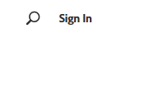
Type your full UNK email in the email field and click on continue
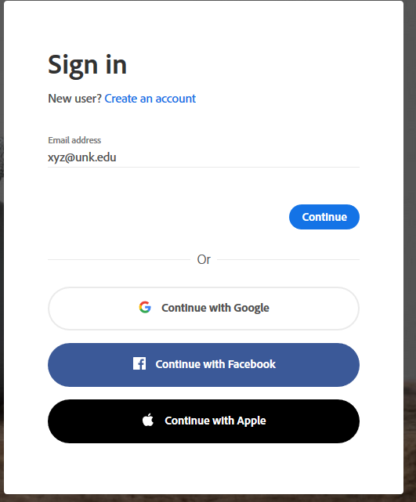
Select Company or School account
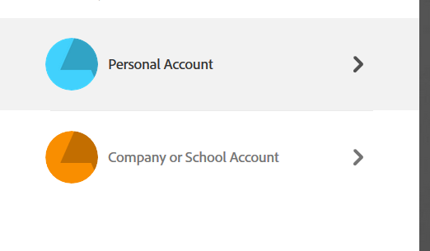
It will then direct you to the UNK SSO page, type your UNK username and password and then authenticate with DUO, if applicable.
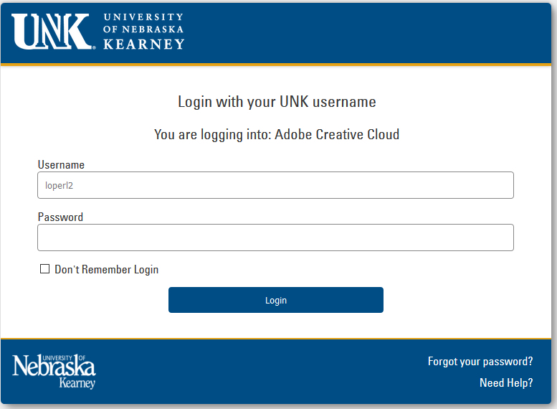
Once signed in, click on Open to open the Adobe Creative Cloud Services
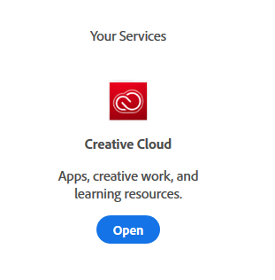
Then, click on “Install the Adobe Creative Cloud App” to install the Adobe CC app on your device. Download and run the file once prompted by your browser.

Once Adobe Creative Cloud is installed, you can install any app from the list, you can even update or uninstall apps from the Adobe CC app in the future.

Enjoy!

