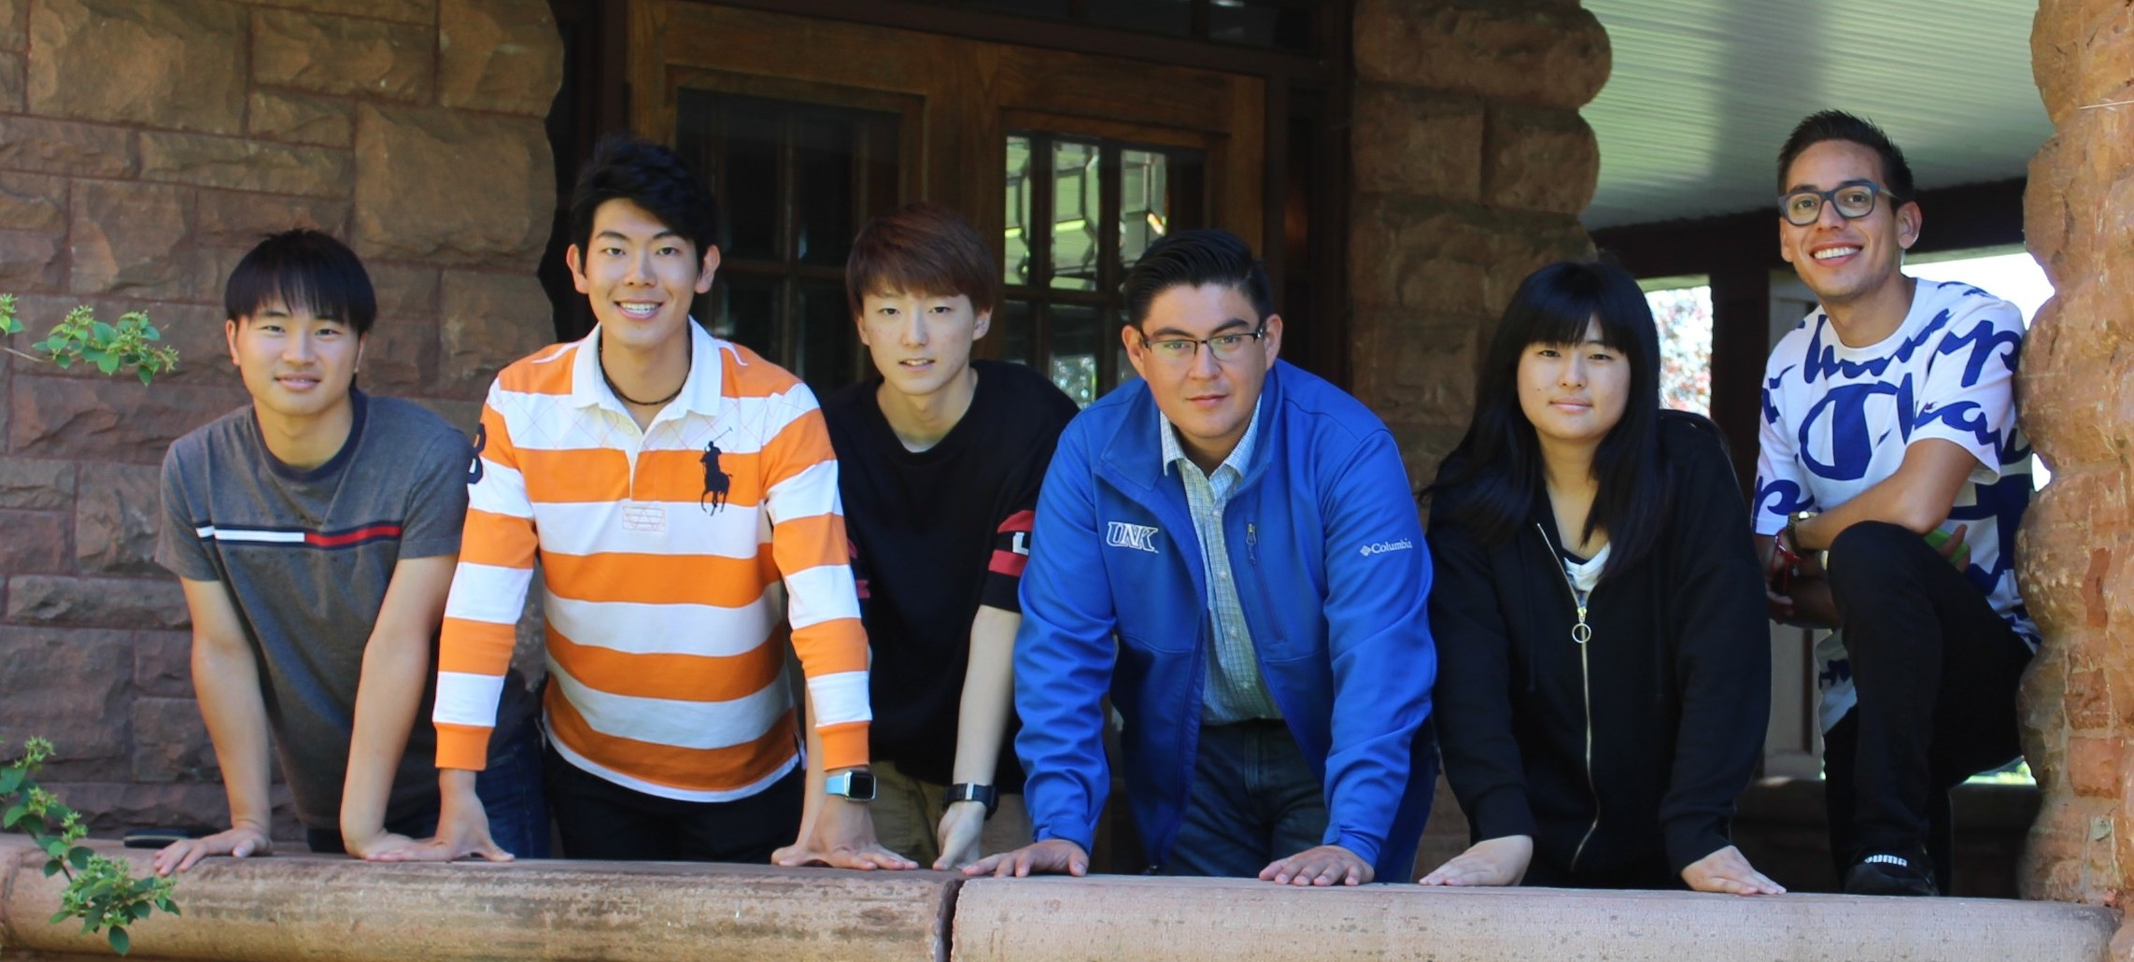

INTERNATIONAL EDUCATION
A WORLD OF OPPORTUNITIES AT UNK

English Language Institute • Summer 2022
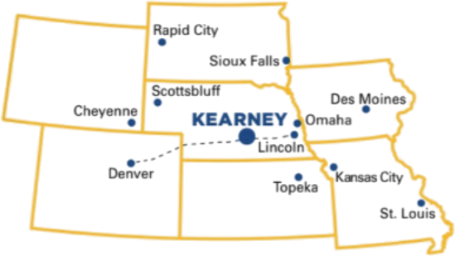
UNK is committed to providing an outstanding education in a personal, student-centered setting. Located in Kearney, Nebraska, a safe and welcoming city of 33,000 friendly people, you can find a world of opportunities at UNK!

Say YES to UNK!
- 24 hours in the classroom per week, no class on Fridays.
- Cultural immersion and activities
- 3 opportunities for TOEFL test & UNK admission.
- Explore your academic area of interest through assign- ments, seminars and tours while building your international network.
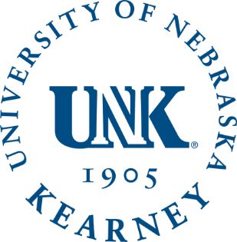
- Small classes dedicated to reading, writing, speaking, listening, grammar, and vocabulary expansion.
- Qualified instructors to personalize each student’s program of study.
- Apartment-style residence halls featuring lounges, study areas, computer labs, and recreational space for student interaction and involvement.
ESTIMATED COST FOR INTENSIVE 10-WEEK ACADEMIC AND CULTURAL PROGRAM

$7,500.00 USD
CAMPUS CONTACT
Traci Gunderson
gundersontd@unk.edu (308) 865-8687

Check us out on Facebook, YouTube and at WWW.UNK.EDU/INTERNATIONAL

