Faculty Research/Creative Activity
Mentor of the Year Award- Due March 30th

The Office of Graduate Studies and Academic Outreach kindly requests applications for the Faculty research/creative activity mentor of the year award. Eligibility requirements are listed below. Please email applications by March 30 to unkgradoffice@unk.edu.

The award winner will be announced at the UNK Student Research Day on April 13. All documents must be submitted to the Office of Graduate Studies and Academic Outreach by March 30 to be eligible for review.

Please include the following items within your submission:

Application form

Cover letter

Current Abbreviated Vita

Attachments of evidence of mentored involvement (Minimum of 3)

Letters of support from former students mentored by the faculty member (Maximum of 3)

Letter of support from a peer or administrator (1)

Submission Process:
All documents shall be submitted at one time and sent via email to unkgradoffice@unk.edu.

Please submit all applications materials to the Office of Graduate Studies and Academic Outreach at unkgradoffice@unk.edu
by March 30th.

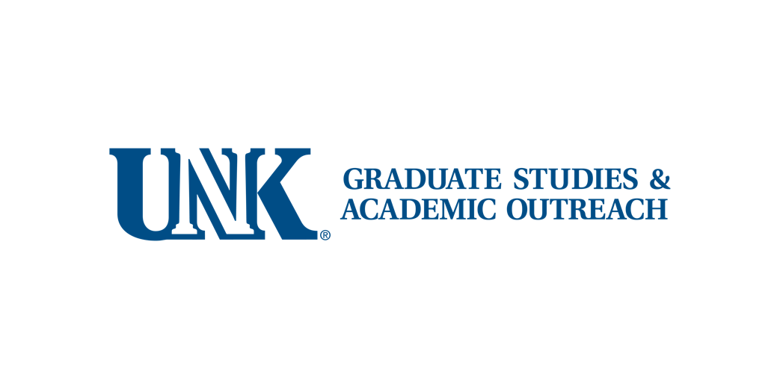

Faculty Research/Creative Activity
Mentor of the Year Award Application

Faculty Member Name:

Department:

College Email:

Mentored Students
Student Name | Department/University | Dates

List of Student Projects, Outcomes, Student Goals/Current Activity
Students Name | Project Title | Project Outcome  (Journal Article, Presentation..) | Student’s Long-term Goal

Attachments:
Cover letter

Current Vita

Evidence of mentored involvement (Minimum of 3)

Number of attachments: ______
Letters of support from former students mentored by the faculty member

Number of attachments: ______
Letter of support from a peer or administrator (1)

