**{Insert Logo or Company Name}**

**Internship Proposal**

**Family Science Internship Position**

**Semester of Internship – Summer 20xx**

**Instructions:** Remove items in blue and replace with your content (in black). After completing the Internship Proposal, return to the student for review. The student will forward to the Career Center indicating their intent to pursue this experience for an academic internship. The Career Center will review and communicate approval of the position through the student.

**Student Contact Information**

Name   
Email Address

Telephone Number

**Company Main Contact Person’s Information**

Name

Title

Email

Telephone

Address

**Internship Details –** Internship will be a minimum 120 hours, but may be longer if specified by employer.

Projected Start Date -

Projected End Date -

Hourly wage and any additional benefits –

Projected hours worked per week –

**Company Information -** (Background, Scope of Business, Size, Location)

**Description / Purpose of Internship –**

Include the purpose of your internship and overall description.

**Overview of Experiences** -   
Provide an overview of responsibilities and experiences. Include a timeline for the internship period (may not be exact, but approximate amount of time spent in each area).

**Projects**

Projects the intern will be assigned, if known. If not definite, provide possible examples.

**Additional Experiences**

Indicate experiences of the internship that were not included above. Examples might include:

* Weekly review with assigned supervisor
* Company outings
* Training and development opportunities for interns

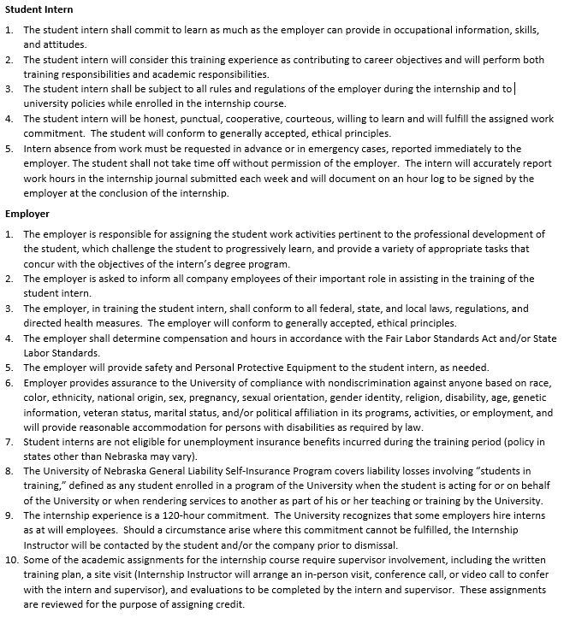**AGREEMENT OF TERMS:** **I have read the student and employer policies below and agree to comply.**

