{Insert Logo or Company Name}
Internship Proposal
Data Analytics Internship Position
Semester of Internship – Summer 20xx

Instructions: Remove items in blue and replace with your content (in black). After completing the Internship Proposal, return to the student for review. The student will forward to the Career Center indicating their intent to pursue this experience for an academic internship. The Career Center will review and communicate approval of the position through the student.

Student Contact Information
Name
Email Address
Telephone Number

Company Main Contact Person’s Information
Name
Title
Email
Telephone
Address

Internship Details
Fall and Spring semester internships must be at least 12 weeks in length.
Summer semester internships must be at least 10 weeks in length.
Projected Start Date - xxxxx
Projected End Date - xxxxx
Hourly wage and any additional benefits – xxxxx
Projected hours worked per week – xxxxx

Company Information - (Background, Scope of Business, Size, Location)

Description / Purpose of Internship –
Include the purpose of your internship and overall description.

Learning Objectives or Milestones
Select the appropriate boxes to indicate which components will be included in the internship.

☐ Work toward solving a business problem affecting the following areas
☐ Organizational operations
☐ Decision making processes
☐ Quality assurance
☐ Strategic analytics
☐ Exposure to how business intelligence impacts rapidly changing technologies such as the internet, e-commerce, and business-to-business applications
☐ Extract business intelligence through analytic techniques to support business functional activities
☐ Utilization of data, network, and system/web-based software
☐ Systems audit
☐ Management control
☐ Infrastructure, data centers, and data communication
☐ Business, financial, and operations
☐ Specification requirements and design development
☐ Compliance with standards
☐ Software quality assurance

Overview of Experiences -
Provide an overview of responsibilities and experiences. Include a timeline for the 12 weeks (may not be exact, but approximate amount of time spent in each area).

Projects
Projects the intern will be assigned, if known. If not definite, provide possible examples.

Additional Experiences
Indicate experiences of the internship that were not included above. Examples might include:
- Weekly review with assigned supervisor
- Company outings
- Training and development opportunities for interns

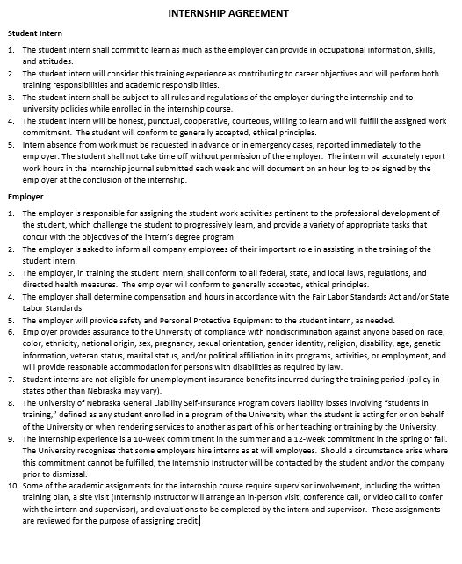
AGREEMENT OF TERMS: I have read the student and employer policies below and agree to comply.

