Cascade Server New Features in Version 7.10.2

- In Context Editing
- Customizable Dashboard
- Advanced Code Editor in WYSIWYG Editor
- User Interface Improvements
- Relationships and publishing of referring assets
- Saved User History
- Smart Version Comments
- Fixed submission buttons in edit screen
- Stale Content Report
- File upload – Drag and Drop
- Google Analytics Overhaul
- Performance Upgrades

In Context Editing
Users can update a page's content while viewing it using the new in-context editing feature and immediately preview their changes as a draft.
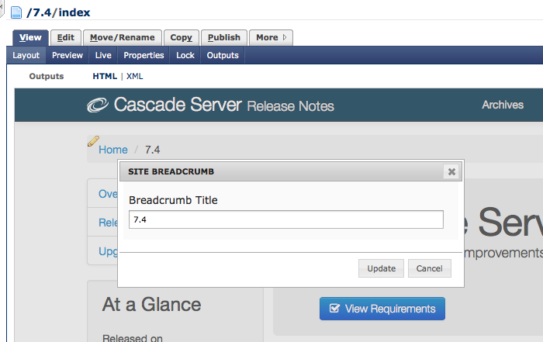
In addition to simple metadata fields, the page's content fields can also be updated.
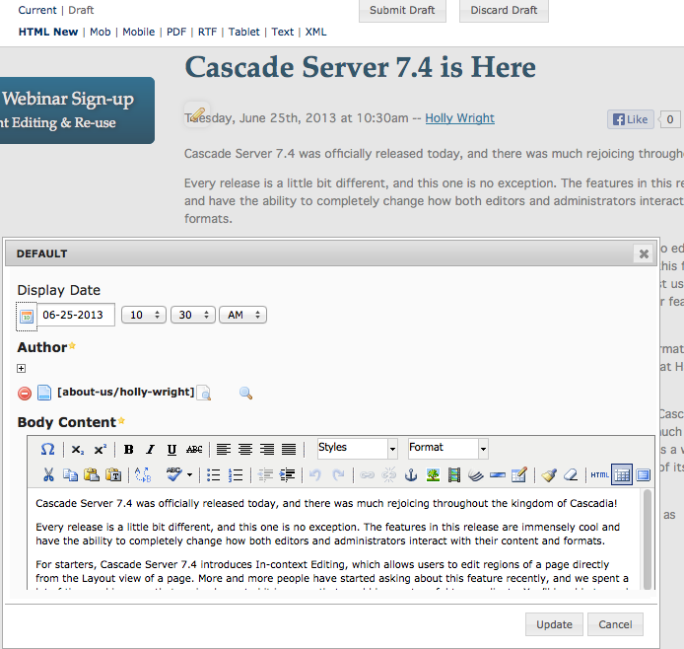
Users with the ability to update the Site's Content Types can configure which content is editable in-context and in which regions.

Direct Edit Blocks
Along with in-context editing, it is now possible to update the content of XHTML, Data Definition, and Text Blocks directly from the page on which they are used. Blocks with no required workflows can be edited from page regions where in-context editing is enabled.

Customizable Dashboard
The Home area Dashboard has gotten a face-lift. Every user can now customize their own dashboard for each site. The dashboard has been split into widgets that can be dragged and dropped to a new position or removed from the dashboard completely.
The Stale Content widget, the Content to Review widget, and the Analytics widgets can also be configured to show specifc information in particular timeframes.
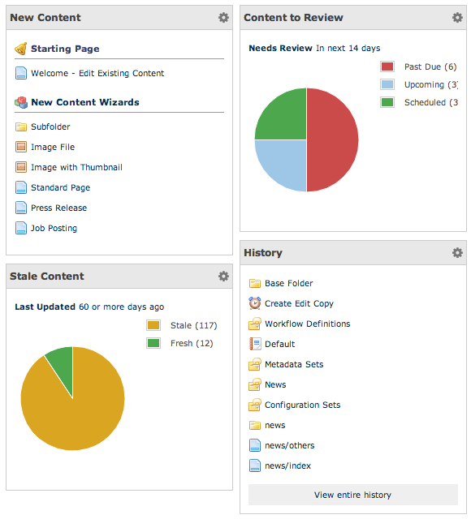
The dashboard is also responsive and compatible with most mobile devices. The layout of the dashboard will seamlessly transition from a 3 column layout down to a 2+1 layout and then finally down to a single column layout as the viewport gets smaller.

Advanced Code Editor in WYSIWG Editor
The Advanced Code Editor introduced in Cascade 7.4 has been added to the HTML View in the WYSIWYG. This adds things like syntax highlight, code folding, line numbers and other convenient features to HTML editing.
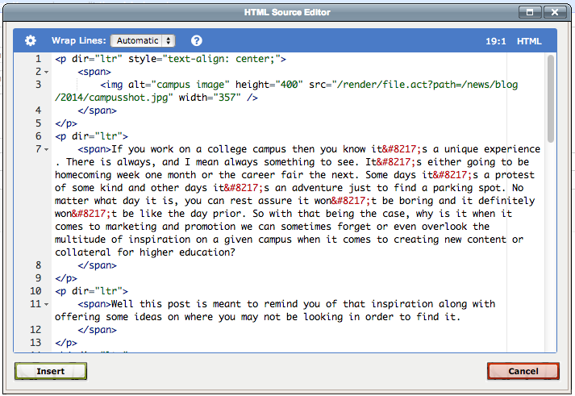

User Interface Improvements
Larger control icons
We've given our control icons a make over to make them easier to distinguish and easier to click.
This includes the links to expand and collapse folders in the left-hand navigation:
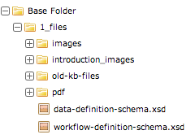
and the controls to re-order, add and remove multiple fields when editing pages and blocks:
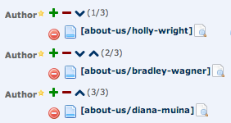

Relationships and publishing of referring assets
Cascade Server 7.8 extends Relationships to more asset types including Pages, Files and Folders. This was one of the most popular ideas on the Cascade Server Idea Exchange. Relationships (formerly called Subscribers) allow users to see referring content. Navigate to a page's relationships and view all assets that refer to that page.
Pages, Files, Blocks and External Links' relationships now include assets that select the given asset in an asset chooser in their structured data in addition to assets whose HTML content linked to the given asset.
Folder relationships list variety of assets that use the folder including Index Blocks that directly index the folder and other home-area assets that are set to use the folder for their expiration folder.
Plus, users can now publish referring assets directly from the Relationships tab by selecting inidividual assets or clicking "Publish all relationships". This is really useful when you make you a change to an asset (such as moving or renaming it) and you want to quickly publish the assets that reference it.
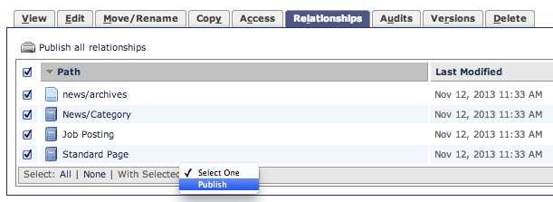

Saved User History
Pick up where you left off with the new Saved History feature! Items in a User's history will now be saved between logins making it easier to get back in the system and get to work. Upon login, the History menu, Quick Links menu, Full History view, and Asset Chooser dropdown suggestions list will be populated with assets recently visited by the user. Plus, the left-hand folder tree will be opened to where you left off previously similar to browsing for files and folders in OS X's Finder or Windows Explorer.

Smart Version Comments
Version comments just got a lot.. smarter. When a draft is saved, the version comments will get automatically populated with a summary of the changes. If an individual field changes, the comment will tell you both the old value and new value. As the number of changes increases, the system adapts to summarizes the changes.
Of course, you can always overwrite the version comments with your own too and we've made the version comments field more prominent.
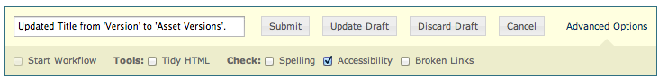

Fixed Buttons and Submit Dialogs
The buttons used to submit assets, save or discard drafts or cancel editing, and the "Advanced Options" section are now fixed to the bottom of the screen and always reachable.
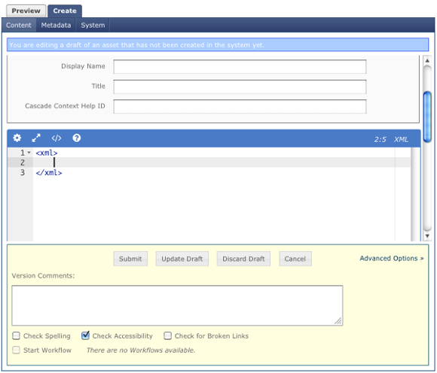

Stale Content Dashboard
The Stale Content dashboard helps users identify and take action on stale content and manage their content reviews. Users can define what content should be considered stale or up for review by using the filters in the Stale Content tab. You can filter content by the last time the content was updated or by the Review Date metadata field.
Only pages and files are considered when listing stale content. The assets listed are also subject to permissions checks; users can only view assets for which they have write permissions.
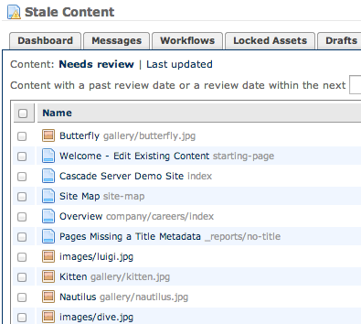
Take control of your stale content by scheduling content reviews or by notifying users of out-of-date content directly from the content reports.
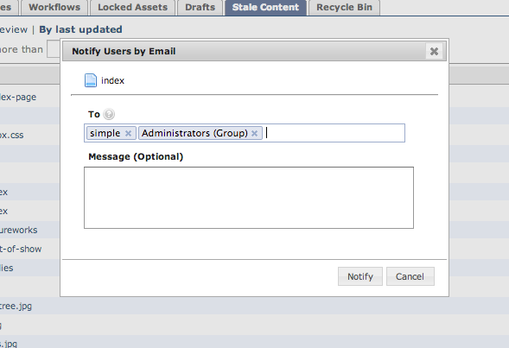
The Dashboard Overview now includes a graph to give you a quick snapshot of your stale content and your content reviews.
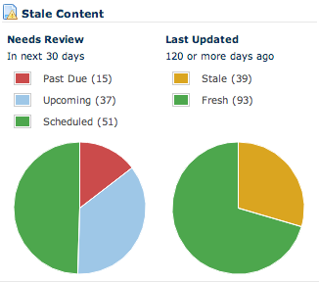

File Upload Improvements
The File create and edit screens have been improved to allow for easier uploading and naming of Files in Cascade. A new drag 'n' drop File upload "drop zone" has been added that allows users to drag files from their desktop directly into the Cascade interface. The system name field for Files will now also be updated automatically to match the name of the file that is uploaded. While the file is being uploaded, a progress bar appears and submit buttons get disabled until the uploading process is complete.
This functionality has also been implemented for file upload fields in Templates, Blocks, Formats, Workflow Definitions, Data Definitions, Site Import, Site creation, Zip Archive tool and LDAP Configuration screen. The contents of Templates, Blocks, Formats, Workflow Defintions, Data Definitions and LDAP configuration will also be refreshed once a file has finished uploading.
﻿File Upload UI
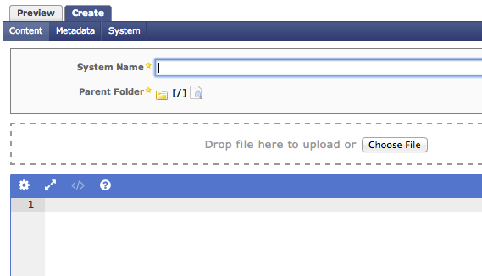

Google Analytics Overhaul
The Google Analytics Connector has undergone some changes. The connector verification process now requires that an access token be copied and pasted from Google into Cascade. This is similar to how Facebook Connector verification works.
The Analytics Connector is also now more up-to-date with Google's Core Reporting API.

Performance Improvements
This release introduces numerous performance improvements to the overall load time of the dashboard, the view and edit screens for assets. In some cases, loading the edit screen is up to 50% faster.

