Outstanding Innovation in Online Teaching Award
Nomination Due May 4th, 2023

Nomination Link: https://unk.co1.qualtrics.com/jfe/form/SV_3vLw9SM1RAhcpRs

Award Description & Criteria
The Outstanding Innovation in Online Teaching Award honors one faculty member a year from the University of Nebraska at Kearney who has contributed significantly to transformative teaching approaches within the online setting to increase student learning and engagement. Innovative teaching is defined broadly to allow nominees to articulate their unique innovative teaching strategies and may include:
- Demonstrates a superior level of teaching effectiveness within the online sector.
- Course materials are presented in an interesting and stimulating manner.
- Shown/proven use & adoption of innovative technology in transformative ways.
- Demonstrates attributes of culturally responsive teaching
- Adoption of innovative teaching strategies using technology
- Utilizes online tools, techniques to promote student centered teaching practices.
- Demonstrates innovative course offerings and/or programs, activities providing experiential learning opportunities for students.
- Active contributor to UNK & beyond related to online learning and teaching.

Nominations may be made by a student, faculty, or administration. No self-nominations will be accepted.

Award Criteria
- Full-time faculty teaching blended or fully online courses including graduate and/or undergraduate, tenured, tenure track, lecturers, or senior lecturers.
- All full-time UNK faculty teaching in the current academic year are eligible to be nominated.
- Two years or more of experience teaching online/blended courses at UNK.

Timeline:
- Nominations: Accepted through May 4th
- Nominee Notified: Within the second week of May. Nominees will be provided details of the award requirements, to submit by August 15, 2023, for consideration.
- Nominee Packet Submission: Due August 15, 2023.
- Winner Recognized: At the online education fall business meeting.

Composition of Award Selection Committee:
- Associate Dean of Graduate Studies & Academic Outreach (GSAO)
- 1 member from the UNK Online Faculty Senate Standing Committee
- 1 staff member of the UNK Online Learning Design Team appointed by the Office of GSAO.
- 1 graduate student appointed by the Graduate Council
- 1 undergraduate student appointed by UNK Student Senate

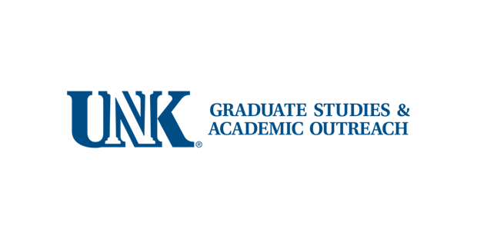

Congratulations, you have been nominated for the Outstanding Innovation in Online Teaching Award. Please review the following information pertaining to materials required to be submitted by August 15, 2023, for you to be considered for this prestigious award. One faculty member will be recognized at the fall online education business meeting.

Award Description & Criteria
The Outstanding Innovation in Online Teaching Award honors one faculty member a year from the University of Nebraska at Kearney who’s contributed significantly to transformative teaching approaches within the online setting, resulting in increased student learning and engagement. Innovative teaching is defined broadly to allow nominees to articulate their unique innovative teaching strategies and may include:
- Shown/proven use of digital technology in transformative ways.
- Adoption of innovative teaching strategies using technology
- Utilization of online tools, techniques, and strategies to promote student-centered teaching practices, while providing equity and inclusion throughout the students’ learning.
- Active contributor to UNK & beyond related to online learning and teaching.

Award Criteria
- Full-time faculty teaching blended or fully online courses including graduate and/or undergraduate, tenured, tenure track, lecturers, or senior lecturers.
- All full-time UNK faculty teaching in the current academic year is eligible to be nominated.
- Two years or more of experience teaching online/blended courses at UNK.

Award Scope: One faculty member per year will be recognized and receive a professional development
stipend, funded by UNK Graduate Studies and Academic Outreach.

Composition of Awards Committee
- Associate Dean of Graduate Studies & Academic Outreach (GSAO)
- UNK Online Faculty Senate Committee
- 1 staff member of the UNK Online Learning Design Team appointed by the Office of GSAO.
- 1 graduate student appointed by the Graduate Council
- 1 undergraduate student appointed by UNK Student Senate

The following materials are requested for submission for the award in digital format (Folder on SharePoint / OneDrive/ Website or ePortfolio, etc.). Nominees have multiple options to submit their teaching portfolios; however, all materials should be provided in an online format and available to review.

- Front page, see attached.
- 1 support letter from one of the following: a) past online/blended student describing the nominee’s innovative teaching practices & personal impact, or b) supervisor providing impact of online/digital innovation(s) (faculty colleagues, chair, dean)
- 3 samples of innovative teaching and learning artifacts with a description and rationale (no more than 3 artifacts).

Outstanding Innovation in Online Teaching Award

This award recognizes an exemplary faculty member for their outstanding contributions to innovative online pedagogy, andragogy, and/or heutagogy* practices academic achievements. Winners receive a certificate and professional development nominal award.

*Definitions listed below.

Faculty Packet:

- Abbreviated curriculum vitae specifically showcasing online innovation, teaching, service, and
scholarship (e.g., awards, recognitions, service/extracurricular activities, presentations,
performances, publications) within the past five years.

- Three samples of innovative teaching and learning artifacts including a description, and
rationale.

- Completion of the table providing: online/blended course number(s) and title of the online/blended course(s) taught, semester/year, student evaluation scores, and samples of students’ comments and include teaching scores for the semesters and mean scores.

Please submit the full packet of material or a link to a folder to review the material to the Office of Graduate Studies and Academic Outreach: unkgradoffice@unk.edu

Education Terminology based on the type and age of the learner:
Pedagogy: teaching of children or independent personalities
Andragogy: adult learners, self-directed
Heutagogy: management of learning for self-managed learners

Outstanding Innovation in Online Teaching Award

Directions: Please complete the following form and submit with your abbreviated curriculum vitae, and three artifacts.

Faculty Name: Email:

Department:

Program:

Name - Three Artifacts |  | Short Description of the Artifact

Course(s) # & Name | Semester/Year Taught  (S23, F22, Su22) | Student Evaluation Score | # of Students in the Course | % student evaluation completion

Student Comments:

