PRAXIS SUBJECT ASSESSMENT REPORT INSTRUCTIONS

February, 2016

Contents:
Introduction…page 2
Helpful Links…page 2
Set up an Account…page 3
Quick Reports…page 4
Custom Reports…page 6
Introduction
The Praxis Subject Assessments (formerly Praxis II) are required for teacher certification in Nebraska. The following information is provided so that you can access test results for your department.
Students who graduate or complete a program without having passed the appropriate Subject Assessment may qualify for a provisional teaching permit, which cannot be renewed. Students may apply for jobs on a provisional teacher permit; however, they must pass the Subject Assessment before they qualify for a full certificate.
Advisors should encourage students to thoroughly read the materials provided on the ets.org/praxis website and the information provided at the time of registration prior to testing. Individuals who do not follow the instructions provided by ETS may lose their registration fees and reservation, which means they must re-register and pay the fees again. For example, students must bring a valid driver’s license or passport to the testing center when they arrive to take their test. Additionally, the name on the ID must exactly match the name on the test registration. UNK students have lost their test fees and their reservation because the name on their ID was hyphenated and the name on their test registration was not. One of our students lost his test fees and reservation because his driver’s license had been expired for four days.

The following information describes the report basics; feel free to experiment with the various available options. For additional information direct from ETS, see their Quick and Custom Analytical Reports Help.

Helpful Links
The following links will be helpful to students, advisors, and department chairs:
- Test numbers and passing scores for the Subject Assessment tests required by Nebraska: http://www.education.ne.gov/EducatorPrep/IHE/SkillsTesting/ContentTestScores.pdf
- Testing locations and dates: http://www.ets.org/praxis/register/centers_dates/
- ETS Study Companion (free) and Interactive Practice Test (for a fee): http://www.ets.org/praxis/prepare/materials
- Additional Test Prep: http://www.unk.edu/academics/certification/praxis-test-prep.php#Test%20Prep
- FAQS: http://www.education.ne.gov/EducatorPrep/IHE/SkillsTesting/ContentTest-FAQ.pdf

Resources for Departments and Students
Educator Certification Office
Website: www.unk.edu/certification
Phone: 308-865-8264
Email: eco@unk.edu
ETS
Website: www.ets.org/praxis (select Nebraska)
Phone: 1-609-771-7395
Email: http://www.ets.org/praxis/contact

Set up an Account
If you have not already set up an account, go to the ETS Client Services website and click “Create Account.” See the screen-shot below for guidance when filling out your request. Be sure to choose the correct UNK account (6467; see below). Your request will be sent to the COE associate dean for approval.

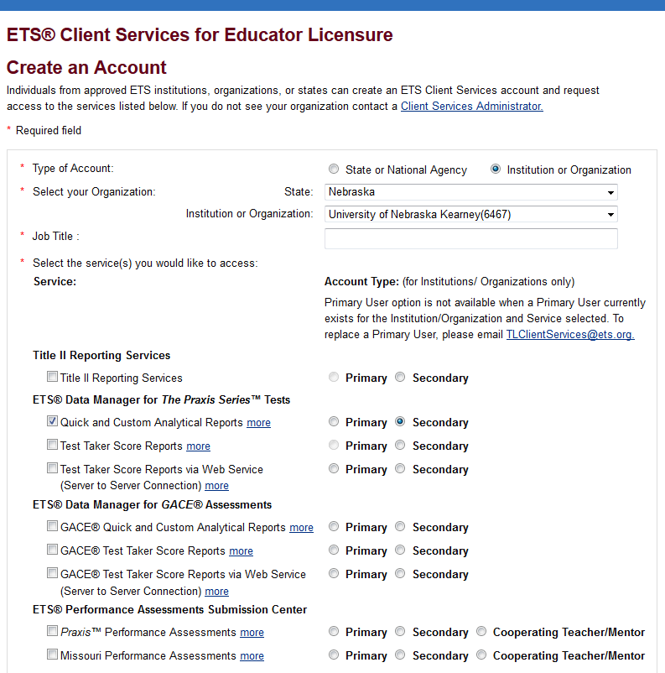
Quick Reports
Follow the information below to create standard Quick Reports. The instructions and screen shots below are to assist you with creating your reports; however, you may choose the options that best fit your needs. If a report includes less than five (5) test takers, use Custom Reports (page 8).

- Log into ETS Client Services
- Click Quick and Custom Analytical Reports
  - Click the Select Criteria tab if it is not selected by default
    - Select Report (left column): Choose the selection made on the screen-shot below, or choose the option you prefer.
    - Report Options (center column): Follow the choices made in the screen-shot below. You will want to choose your test number(s) (click here for Nebraska test numbers) and the appropriate date range. You may also choose the “Duplicate Examinee” that you prefer.
    - Choose Variables (right column): Make the selection on the screen-shot below, or choose the option you prefer.
    - Click Next.

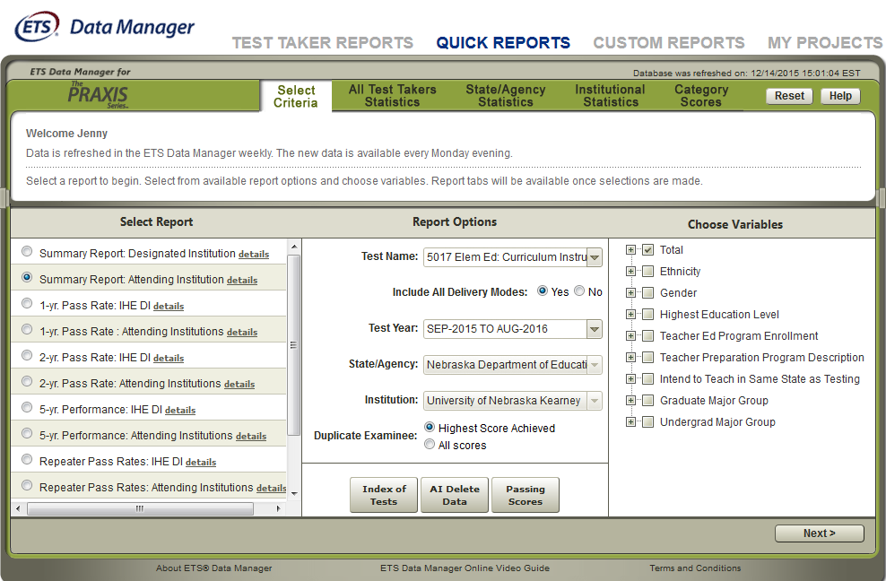

  - All Test Takers Statistics tab
    - The Nebraska passing score should appear in the blue box. The red and green scores default to five points above and five points below passing.
    - Click Export.

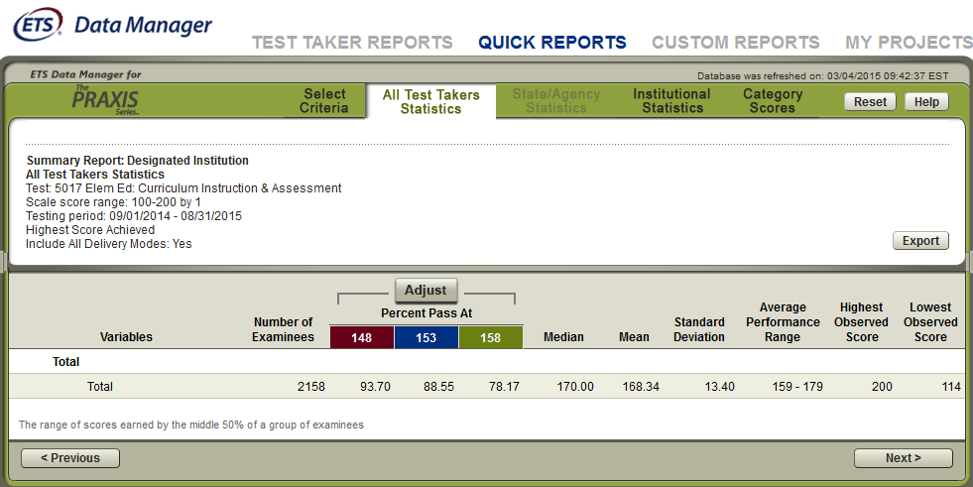

- Export Reports
  - Make the choices shown in the left column. (The Category Scores selection gives you score information on each of the content categories.)
  - Choose your format preference in the right column.
  - Click Done.

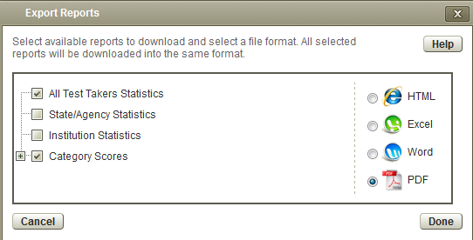
Custom Reports
Follow the information below to create Custom Reports. Custom Reports are especially helpful when you have fewer than five examinees within one academic year. The instructions and screen shots below are to assist you with creating your reports; however, you may choose the options that best fit your needs.

- Choose Custom Reports
  - Select Criteria:
    - Choose your Test Name (click here for a list of Nebraska tests).
    - Make selections shown on the screen-shot below and click Next.
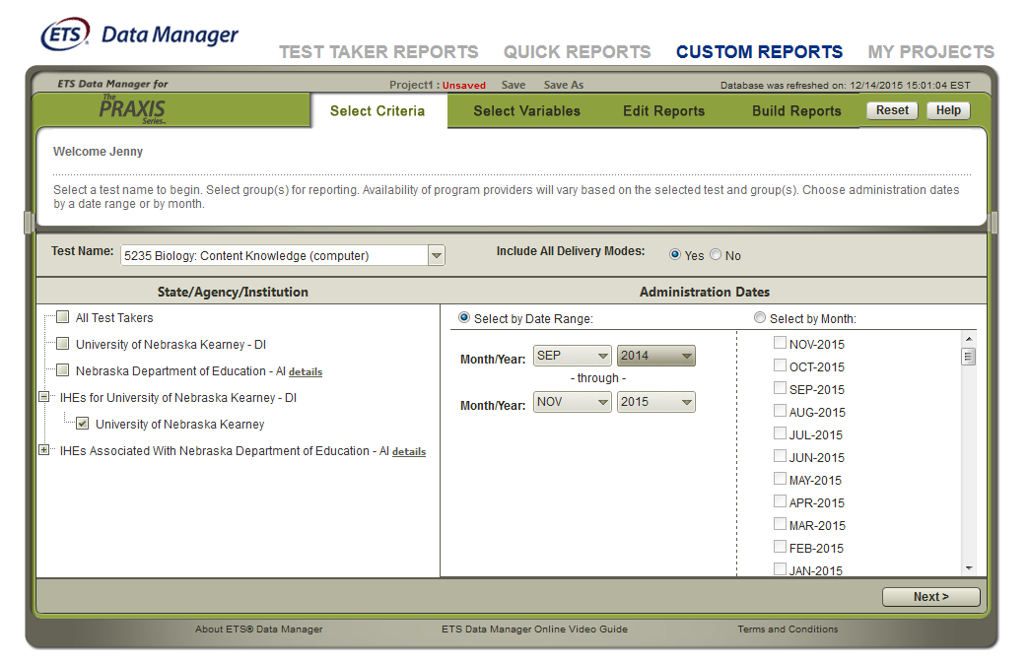

  - Select Variables: Make selection on screen-shot below and click Next.
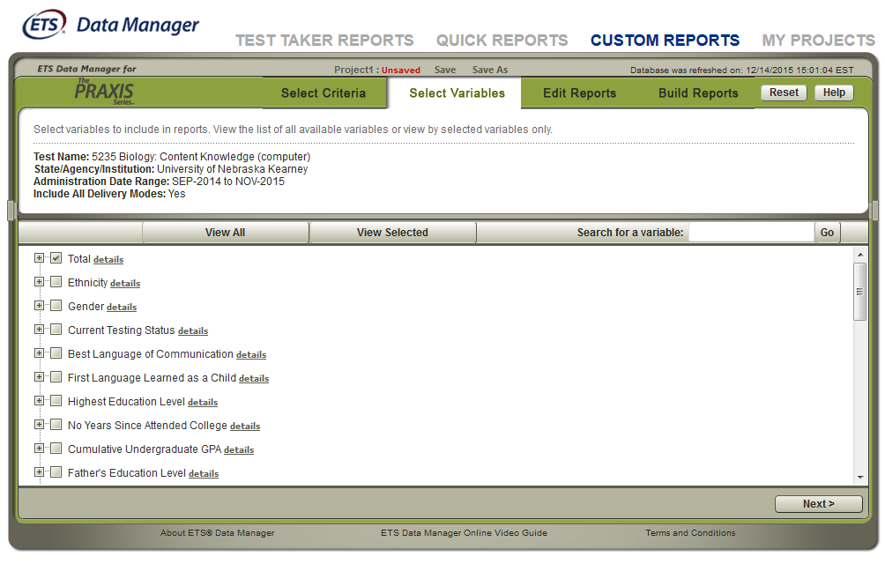

  - Edit Reports:
    - From Preview | Edit | Delete | Copy in the first column, choose Edit.

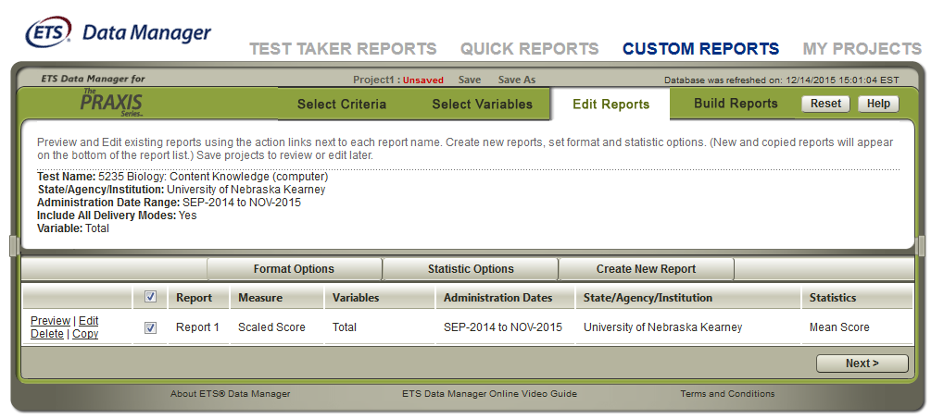

      - Name your report
      - Choose your score type.
      - Click Done.

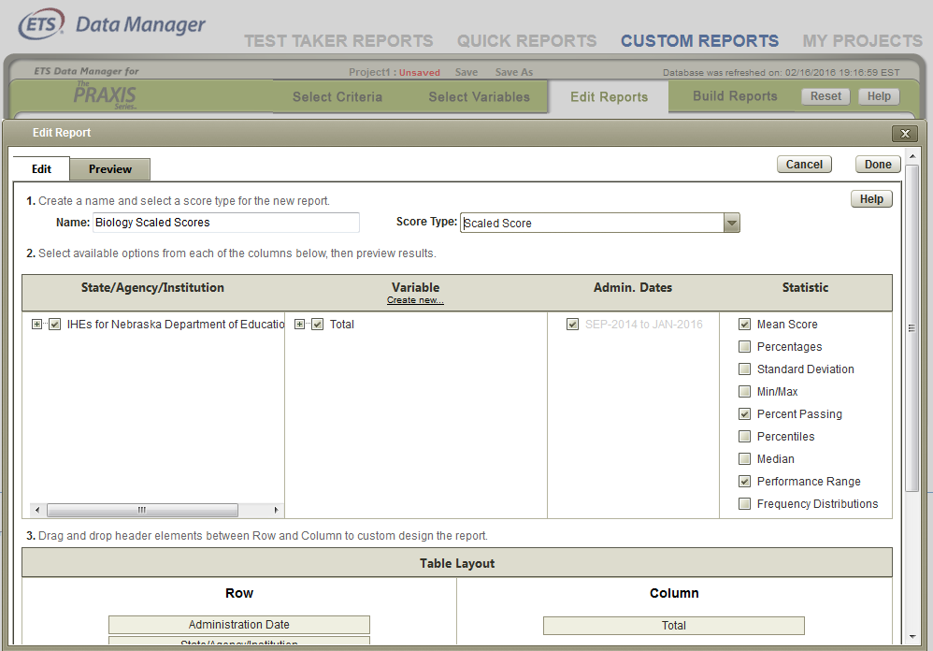

    - Click Next.

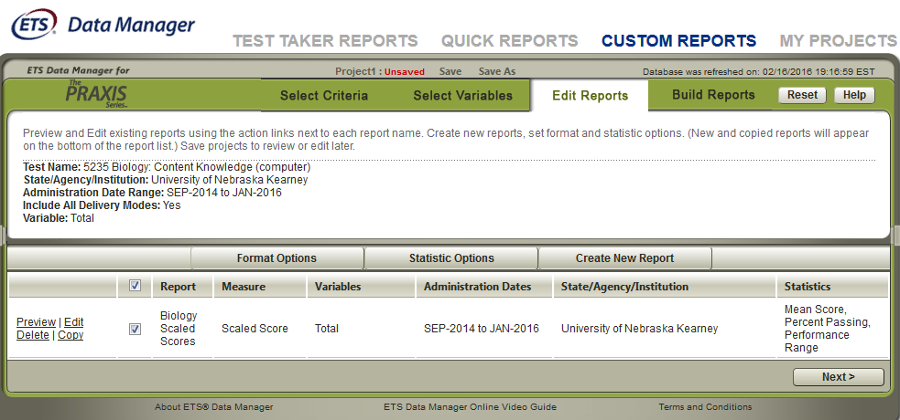

  - Build Reports: Click Export.
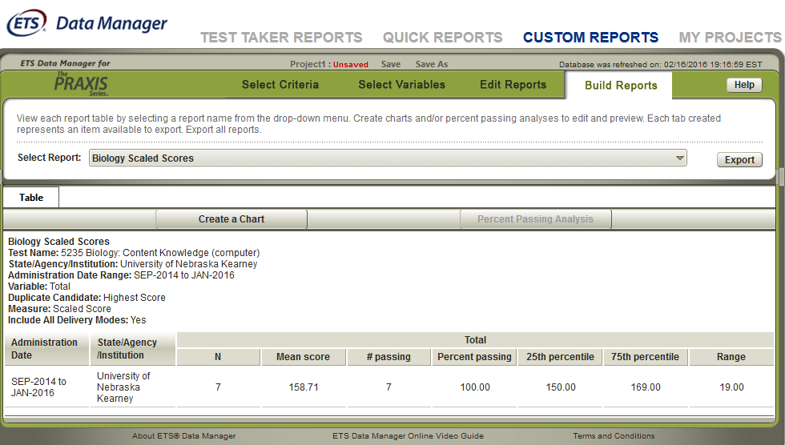

  - Export Reports
    - Make the choices shown in the left column below.
    - Choose your format preference in the right column.
    - Click Done.
