Bauhard

student Managed investment fund
  - Annual Report 2019

TABLE OF CONTENTS
Investment Policy Statement 3
Bauhard Fund History 4
Investment Methodology 5
Sector allocation 6
Sector Overview 10
Current sector holdings 18
Portfolio Performance 58
Lessons Learned 65
Analysts 67

Investment Policy Statement

Objective
The primary objective of the Bauhard Student Managed Fund is to provide an experiential learning process for student. The secondary objective of the fund is to match the return of the S&P 500 Index Fund.

Constraints
Several constraints are in place to regulate the management of the Bauhard Fund. Holdings within the portfolio are limited to U.S. equities. The management team does not engage in either the trading of derivatives or the short selling of securities. Further portfolio constraints include a minimum per share price of $5.00 and stock positions limited to a maximum of five percent of the portfolio’s value at the time of acquisition.

Procedures
Student analysts prepare and present equity analysis reports to the investments and portfolio management classes. Students consider portfolio diversification and a long-term investment horizon while analyzing each potential equity. All trading decisions require a two-thirds anonymous vote in order for an equity to be added or removed from the fund.

Bauhard Fund History

The William L. Bauhard Student Managed Investment Fund provides students at the University of Nebraska at Kearney a hands-on learning experience by allowing the managers to invest in the stock market. Mr. Bauhard, a former financial service and telecommunications executive, provided a generous leadership gift to start the fund. Additional funds were provided by Jack Connealy of JFC Financial Services in Lincoln, NE; Ron Eckloff, a certified financial planner serving the Kearney community; Financial Leaders Student Association; Jay Landell of the Wells Fargo Foundation; and Securities America of Kearney.
The student investment portfolio is managed by senior-level undergraduate students specializing in finance and accounting. The program exposes students to real-world training in securities analysis and portfolio management. Student analysts are responsible for researching industry sectors and periodically presenting potential investment opportunities to the class. Throughout the learning process, students also have the opportunity to learn about career-enhancing opportunities by competing in investment competitions to showcase the skills they have acquired. In addition to the experiential learning opportunities, income generated from the fund’s investments may be utilized for future student scholarships.

Investment Methodology

Top Down Allocation
The student managed fund follows a top-down investment strategy. This method entails an allocation process whereby a certain percentage of the Bauhard Fund’s performance is attributable to the selection of equity securities. The S&P 500 Index is used as a comparable benchmark portfolio to the Bauhard Fund, and as such, its investment sector allocations are considered in the equity selection process. From there, managers study equities in under allocated sectors to determine their true value in the market.

Equity Selection
The decisions to add or reject securities are based on the student analysts’ opinions regarding the valuation of the securities compared to the current market prices. Student fund managers compile extensive reports that detail a company’s vital characteristics, including the stock’s underlying financial strengths and possible opportunities. These reports are reviewed and critiqued by all of the student analysts in the class. Furthermore, the smaller student groups present their findings to the class upon the completion of their reports. These presentations allow student managers not associated with the presenting group the opportunity to ask questions and make comments regarding the presenting analysts’ assumptions and conclusions. After a brief period to formally respond to student questions and inquiries, the entire class of student analysts vote on whether to purchase, sell, or hold the proposed securities. The motion to purchase, sell, or hold a proposed security passes if two-thirds of the student analysts vote positively in an anonymous vote.

Portfolio Monitoring
As a means of tracking the Bauhard Fund’s performance throughout the course, student analysts are asked to present market updates to the class. These presentations include the weekly performance of each of the individual securities held within the Bauhard Fund and their corresponding public news stories. In addition, student analysts report the performance of the sector allocations within the fund and the returns of the appropriate comparable exchange traded funds. Furthermore, the performance of the Nasdaq, S&P 500 Index, and Dow Jones Industrial Average are highlighted and compared to the Bauhard Fund’s weekly returns.

Sector allocation

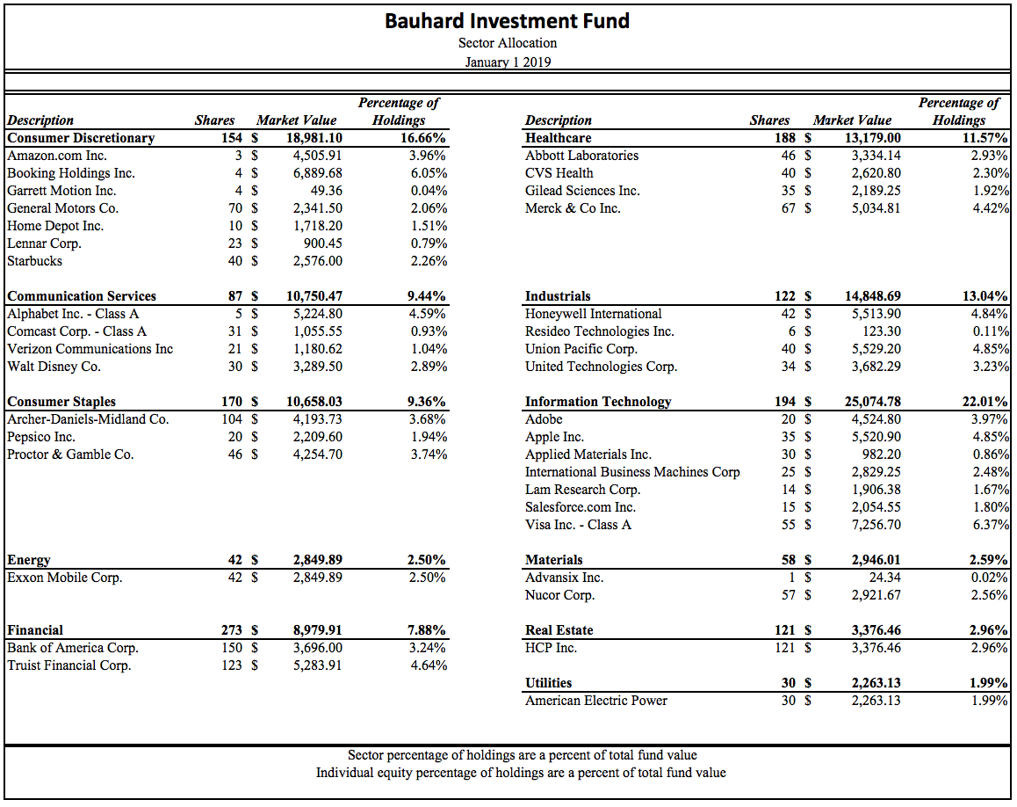

As of January 1, 2019, the Bauhard fund was composed of 36 equity positions across 11 sectors. The Bauhard Investment Fund is overweight in 4 sectors when compared to the S&P 500: consumer discretionary (+6.65%), consumer staples (+2.00%), information technology (+1.92%) and industrials (+3.82%). There are 5 sectors that are underweight: healthcare (-3.73%), energy (-2.92%), financial (-2.35%), utilities (-1.28%), and communication services (-4.01%). The real estate and materials sector holdings of the portfolio approximately match the S&P 500 in terms of percentage of total portfolio holdings.
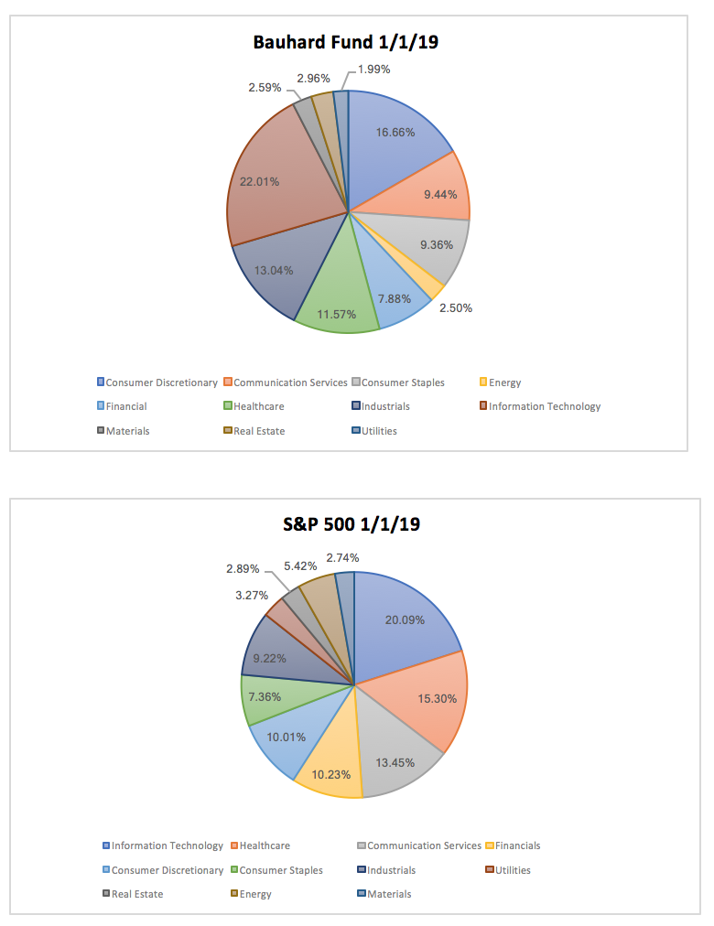
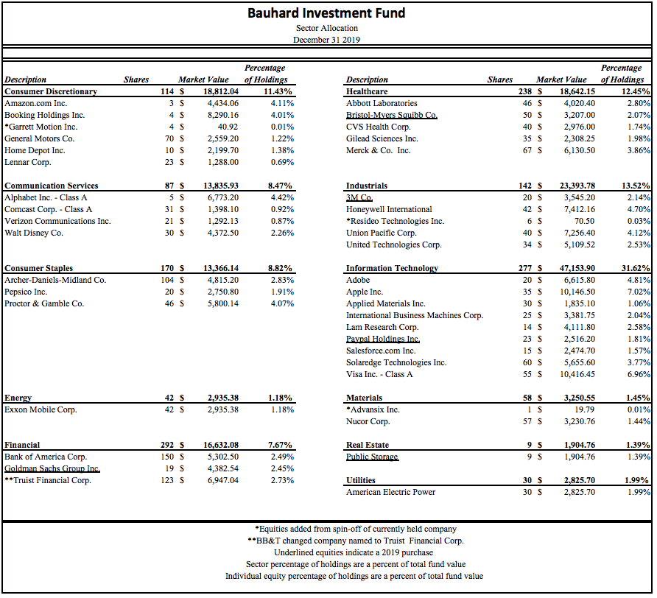

As of December 31, 2019, the Bauhard Investment Fund was invested in 40 equity positions across 11 different sectors. There are 4 sectors that are overweight when compared to the S&P 500: consumer discretionary (+1.68%), consumer staples (+1.62%), industrials (+4.47%), and information technology (+8.42%). There are 7 sectors that are underweight: communication services (-1.92%), energy (-3.17%), financial (-5.28%), healthcare (-1.75%), materials (-1.20%), real estate (-1.54%), and utilities (-1.33%).
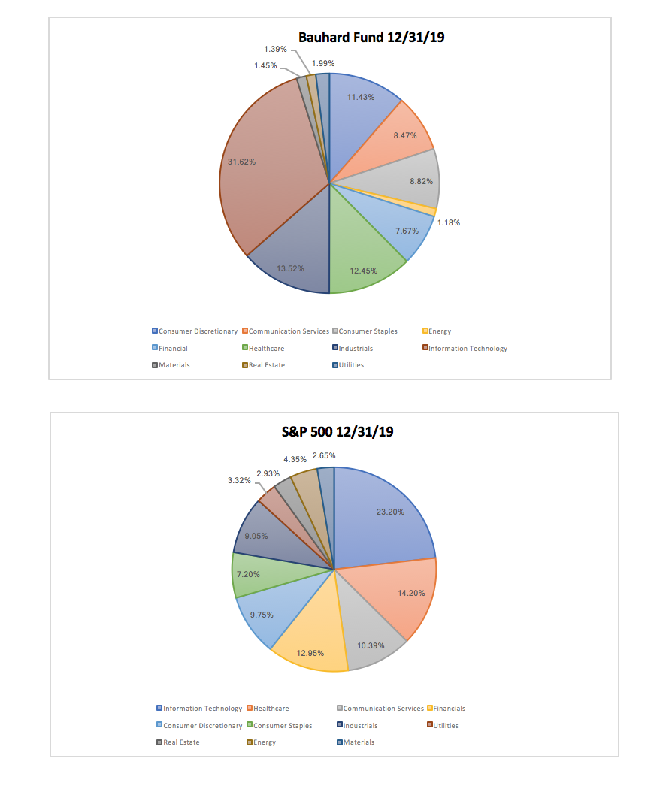

Sector Overview

Basic Materials

Description
The basic materials sector primarily includes those dealing with natural resources and raw materials. Raw materials are natural substances that can be reused but are limited in quantity. Firms and companies in this sector include production in metal refining, mining, forestry, and construction.

Value Drivers
The basic material sector is driven and dependent on a growing and strong economy. Some of the most common types of basic materials are the mining industry, which produces metals and ores, and the forestry industry, which produces paper and lumber. Developing countries help drive this sector due to the young and developing infrastructure. Higher demand in other consumer goods can drive the demand for basic materials due to the required resources. Raw materials drive economic growth because of other sectors’ dependency on said materials for other goods and products.

2019 Risk Factors
Companies within the basic materials sector tend to be more sensitive than other sectors to fluctuations in the market. Trading relationships between China and the United States have raised concerns over how the market would react. As negotiations began to lead to new trade deals, the concerns eventually subsided. Overall, the basic materials sector in 2019 demonstrated relatively stable growth and revenue despite the trade wars.

Forward Looking Risk Factors
While tensions between China and the United States have subsided, the outbreak of the COVID-19 coronavirus has shocked the markets in early 2020. Recovery from this outbreak will be a struggle as consumers have to deal with a period of reduced revenue. China is one of the largest consumers in the world, and the reduced production from this virus will take its toll on the materials sector. As the global outbreak subsides, the market should look to recover, and the basic materials sector will follow. As long as consumers continue to spend less, companies will tend to restrict production of goods, furthermore leading to fewer required basic materials.

Consumer Discretionary

Description
The consumer discretionary sector refers to non-essential goods and services. Companies involved in fashion, hotels, restaurants, entertainment, retail, and automotive, just to name a few, fall under the large sector of consumer discretionary. These products are consumed in a non-essential manner, normally when the economy is in a healthy state. Consumers will normally spend more on discretionary items and services if spare cash is on hand. Consumer discretionary can then be divided into two sub-categories: durable and non-durable. The durable segment contains goods that last for long periods of time such as jewelry and vehicles, while non-durable goods and services are consumed within a short amount of time like a vacation.

Value Drivers
The consumer discretionary sector is largely driven by how well the economy is performing and the trend of spending. The majority of companies within this sector will sell more products depending on the expendable income of the consumer. Non-essential goods are very dependent on disposable income. This trend tends to be cyclical. The companies within this sector tend to operate and perform at a similar level to the overall economy.

2019 Risk Factors
The economy performed admirably in 2019 and the consumer discretionary sector shows a similar result. Market growth was steady with the sector outperforming the S&P 500 for the majority of the year. Because of the strong growth of the economy, the sector flourished off of booming sales and great business. This sector has cyclical tendencies so companies within this sector may be preparing for a downturn in sales in response to a positive performing year.

Forward Looking Risk Factors
The impending outbreak of COVID-19 will be a good test after initially scaring the public. Consumers are hesitant on discretionary purchases and the sector is slowed. Companies are forced to cut spending and production as buyers have ceased spending during this recession. If the market takes a bearish turn for the long-term, companies may need to withdraw long-term savings or debt to stay afloat. Because the market for discretionary purchases is cyclical, firms should be prepared for the upcoming challenge. However, the longer consumers are weary from purchasing luxury and non-essential items, the more difficult it will be to recover from this disaster.

Financials

Description
The financial sector includes commercial banks, insurance companies, consumer lenders, investment firms, and other institutions that provide financial services to the public and private sectors. Companies within this sector are usually relatively stable, as many are mature, well established firms. The sector is one of the most regulated in the S&P 500, due to the sector's ability to drive economic growth by fueling the consumer and business wealth.

Value Drivers
The spread between lending rates and interest rates on loans and mortgages is the primary driver of revenue for the financial sector. Rates provided by financial companies are primarily based on the monetary policy decisions of the Federal Reserve. Expanding economies also drive value for the sector. As economies expand, people look for financing options to capitalize on the increased spending in the economy. This increased demand for lending can provide larger revenue generation for companies within the sector. Moderate volatility within the markets also creates opportunities for firms within this sector to capitalize on transaction-based fees which leads to revenue generation.

2019 Risk Factors
The financial sector was under pressure during 2019 as interest rates were lowered and global trade and economic activity wavered. Despite these hardships the sector realized a 28.23% return. Drivers of disruption were more forceful and persuasive than what we have seen in recent years. Firms made substantial investments to reshape the landscape (ex. online banking and trading). This, along with the broader market actions, has led to the disruption of economic, geopolitical, demographic, and environmental changes. Merger and acquisitions continue to influence this sector as institutions with the lack of scale or differentiated capabilities are more susceptible to the effects of globalization.

Forward Looking Risk Factors
With the economy and markets contracting due to COVID 19 firms will be waiting for Q1 reports to analyze the material impact of the virus. Tightening margins due to interest rate cuts will lead to lower profits for the financial sector in 2020 if the virus spread isn’t contained with businesses returning to normal operations. The year began with a circuit breaker halt on trading, this uncertainty will potentially lead firms into safer risk averse business strategies for the rest of the year.

Healthcare

Description
The healthcare sector consists of companies that provide healthcare supplies and services and companies that research or produce healthcare products. The sector is further subdivided into a multitude of categories. Firms operating in the sector can be classified as hospitals, managed healthcare organizations, healthcare technology consulting firms, pharmaceutical companies, and life science corporations. Firms with patients must ensure that they are both providing proper patient care and offering an adequate return to their investors.

Value Drivers
A shift toward value-based care has been an important value driver for companies in the healthcare sector. Recent increases in mergers and collaborations between health plans and care delivery organizations have allowed firms to capitalize on their strengths while mitigating exposure to firm-based weaknesses that may exist. Recent developments in the fields of artificial intelligence and telemedicine have also allowed companies to increase their operating efficiency by streamlining their operations. These improvements have led to reductions in costs to consumers, improved quality of care, and an overall more positive consumer experience.

2019 Risk Factors
The healthcare sector in 2019 underperformed the overall S&P 500. This sector faced challenges in 2019 that led to an underperformance, contributing factors include slowing corporate earnings and trade tensions. Risk factors like the Affordable Care Act, regulatory uncertainty and fiscal policy were some of the larger politically charged issues that firms faced within the healthcare sector. Throughout the year the current Trump Administration pushed for easing of regulations within healthcare, providing opportunities for new growth especially within the telehealth industry.

Forward Looking Risk Factors
The healthcare sector will face complex challenges in the upcoming year including rising costs, changing consumer expectations, and new market entrants as affordability and ease of access become key industry driving factors. The capital investments that will drive growth for firms within the healthcare sector include virtual care technologies and or updating existing facilities instead of expanding into new communities. The transformation of digitalized healthcare will require firms to increase spending in new equipment and software that will optimize operational performance.

Industrials

Description
The industrial sector includes companies that provide products and services that help other corporations operate. The services provided include many industries ranging from aerospace and defense, machinery, airlines, logistics, and commercial services.

Value Drivers
As technology advances within the industrial sector, efficiency in production has revolutionized how the sector has grown. Products are made with more precision and control resulting in an increased life cycle of these products. As other companies need foundational operations, the industrials sector will grow off of the increasing demand of these services. The industrial sector has a broad industry lineup with many types of services available.

2019 Risk Factors
Trade tensions between China and the United States have raised questions. Questions regarding this conflict have raised concern over possible tariffs. Outsourcing materials such as steel will be difficult and expensive for companies who receive tariffs. During this negotiation time, profits and revenue have struggled to find a settling point as political issues have affected the markets. While relative job growth in 2019 performed well, the demand for skilled workers has gone unchanged. With a low supply of qualified workers, this understaffing has been and will be a problem to monitor.

Forward Looking Risk Factors
The world is slowly turning into an online market. Industrial companies are implementing cloud services, online ordering, and integrating into the web easier than ever. This generation gap of production has a shrinking talent pool for employees in the industrials sector. The skill gap will continue to grow as the positions open up from retirees. As technology continues to advance, jobs can also be removed by robotic replacements. The industry is expected to grow, but with a downward growth in jobs, a possible technology takeover in the industrial workforce may occur soon.
Real Estate

Description
The real estate sector consists of companies focused on residential, commercial, and industrial real estate. These companies are frequently operated as real estate investment trusts (REIT). The sector generates income from owning, operating, or financing real estate

Value Drivers
Land generally appreciates in value over time as more people and companies compete for the finite resource. This appreciation provides companies increased revenues in the form of both gains on the sale of properties and increased rent revenue on their properties. This income is usually paid out in dividends, especially in the case of REITs. Companies can increase the rate at which their properties appreciate in value depending on the developments that occur on the properties. Innovative developments which raise demand for the property and its surrounding area can greatly enhance the returns seen by investors. This rapid increase in value is why development of real estate properties is the primary value driver for the sector.

2019 Risk Factors
The Federal Reserve cut interest rates three times during 2019 reversing all the rate hikes in 2018. The real estate sector was balanced throughout the year as home buyers took advantage of lower interest rates and home sellers were able to capitalize on low inventory in the market. The sharp drop in interest rates led to a surge in new home sales as mortgage rates declined. Economic activity and monetary policy led to an increase in demand and higher home prices which increase sector profits in 2019.

Forward Looking Risk Factors
The 2020 risk factors are highly uncertain as the year began with high volatility in trading over the COVID 19 outbreak. The Federal Reserve slashed interest rates to 0% in Q1 2020. The market is waiting for key factors including quarterly earnings and GDP reports to gauge the impact and severity on firms, which will determine the unemployment levels for 2020. If this uncertainty leads to lower demand in the market, housing prices will begin to decline leading to smaller margins for the real estate sector.

Information Technology

Description
The information technology sector includes companies that produce software, hardware, and semiconductor equipment. Many firms also specialize in providing technological services and solutions. Products include phones, computer systems, and technological equipment. Services range from IT consulting to application and systems software.

Value Drivers
The primary value driver for the information technology sector is its ability to produce innovative products and services. Because of how integrated a firm’s products and services are, technology companies can implement sweeping updates to their business model much faster than any other type of company. This advantage leads consumers to pay high premiums for access to the most innovative companies and their products and services.

2019 Risk Factors
The primary risk factors that influenced firms in 2019 included data security, ransomware attacks on the Internet of Things and regulatory policies. The main drivers of growth for this sector include cloud computing, artificial intelligence, and the blockchain evolution. The information technology sector focused on increasing the connectivity and user experience. The financial and industrial sectors have lent to some of this sector's growth as financial institutions try to keep up with the growing demand for online services, they will continually work with the information technology sector to innovate and release new products.

Forward Looking Risk Factors
Looking forward it is clear there are many opportunities for firms to drive growth by providing innovative solutions to both businesses and society. The information technology sector will face a large demand for hybrid-cloud services in 2020 as firms adopt multi-cloud solutions that integrate cloud services from multiple providers. Artificial intelligence products and super computers will begin to dominate this sector as they offer invaluable data analysis and forecasting capabilities to businesses and consumers.

Consumer Staples

Description
The consumer staples sector comprises companies that manufacture and distribute food, beverages, tobacco products, non-durable house goods, personal products, and food and drug retailers.

Value Drivers
Securities within this sector tend to be less subjective to economic cycles making them appealing to investors. Consumers will continue to buy these essential products even during times of economic instability. Furthermore, the purchasing power of consumers is rarely affected by changes in the market regarding consumer staple stocks. This makes investment in these securities appealing.

2019 Risk Factors
Currently, the consumer staples sector has seen risk from rising regulations and disruptions within the supply chain. Furthermore, the coronavirus will continue to impact this industry and how the goods and services are distributed. Added tension from trade disputes adds uncertainty to firms operating in this sector. However, despite these risks the consumer staples sector has remained a stable investment.

Forward Looking Risk Factors
Consumer staples have performed relatively well during periods of economic slowdown. Investors tend to be attracted to safer, stable equities during times of crisis. As for the COVID-19 outbreak, the consumer staples sector has been doing well, as consumers will always buy the goods necessary for survival. The problem isn’t necessarily the volume of products to be sold, but rather the margin on the goods and services. Foreign policy can be a threat to this sector as tariffs and negotiations can reset the pricing strategies companies may impose. The COVID-19 outbreak is a good test, but will still hurt if companies in this sector remain non-profitable.

Energy

Description
The energy sector consists of companies that participate in supplying energy or producing it through a means of exploration and development of oil or gas reserves, or oil and gas drilling and refining. This sector also encompasses firms that partake in renewable energy practices and coal.

Value Drivers
In the Energy sector, advancements in technology drive growth for firms. Today, many advancements come from the way oil and coal are harvested and refined. As it becomes easier for firms to produce their goods, investors begin to see larger yields due to consumers having easier access to products. Furthermore, this industry is driven by the constant demand for energy related products. Due to modern globalization, much of the trade done between entities around the world requires some form of energy to transport goods and services from one location to another.

2019 Risk Factors
Geopolitical conflicts and disturbances in supply have contributed to the riskiness within this sector. Much of the poor performance in this sector has been driven by low crude oil prices. Although this means lower prices on gas for consumers, it has only increased volatility within the market.

Forward Looking Risk Factors
Much of the risk factors heading into 2020 are the same as those of 2019. The sector will continue to be affected by geopolitical disputes in the future. As trade tensions rise the securities within this sector become increasingly unpredictable. Furthermore, rising regulations within this industry makes it difficult for firms to operate.

Communication Services

Description
The telecommunications sector comprises companies that participate in communication on a global scope. Often this communication takes place over the phone, internet, airwaves, cables, wires, or wirelessly. These firms laid the groundwork that has allowed media to be transmitted via audio, video, voice, or words. The largest enterprises within this sector are firms that provide services through the internet, telephone, satellite, and cable.

Value Drivers
In the Communication Services sector the push for innovation and new technology drive the industry. Due to this industry encompassing several companies that are used by consumers daily, cutting edge technology and staying at the forefront of innovation is a key element to success. Currently, the widely anticipated release of 5G (fifth generation) cellular wireless technology has investors hopeful for positive gains within the sector. Once this technology is implemented and standardized, daily use from consumers will increase demand for communication services.

2019 Risk Factors
The largest risk affecting this industry was the inability to prepare business models for the anticipated release of 5G cellular wireless technology and the Internet of Things. Due to the ever-changing landscape of the industry, the success of firms is intertwined with their ability to adapt and implement expansion policies that incorporate innovative and cutting-edge technology.

Forward Looking Risk Factors
In the digital media, users are increasingly more concerned with security and privacy. Firms within the telecommunications sector must implement measures that ensure the quality and standard of service that their consumers demand. Furthermore, this sector is becoming more regulated to ensure data protection. Failure to meet these regulations and the quality of service demanded by their customers would result in a decrease in revenue growth.

Utilities

Description
The Utilities sector comprises companies that participate in the supply of basic resources such as water, sewage, electricity, dams, and natural gas. Although firms encompassed in this sector provide a steady stream of revenue for investors, this industry is heavily regulated.

Value Drivers
In the Utilities sector, securities tend to perform best when concerns of trade and growth are presented and vice versa when these fears fade away. This is because utilities are amenities that consumers need at all parts of the business cycle. Furthermore, this sector is positively impacted at the sign of falling interest rates. This is due to investors pursuing higher yields as the high fixed costs of this industry stay the same.

2019 Risk Factors
The largest risk that impacted the Utilities sector during 2019 were regulations. Many of the firms that operate within this sector conduct business in multiple states. This means that firms have to tread lightly in order to abide by the different rules and regulations set by the different states they operate in.

Forward Looking Risk Factors
Securities within this industry are often classified as defensive stocks. This suggests that investors tend to add such stocks to their portfolios to mitigate risk when more volatile begin to fail. Moving forward, the risk attached to this sector begins to become more pressing in times of economic prosperity due to the defensive nature of said securities.

Current sector holdings

Materials

NUCOR CORP.
Ticker: NUE
Beta: 1.63

Description
Nucor Corporation is one of the world’s largest manufacturers of steel products. These products include carbon and alloy steel, steel joints, steel deck, cold finished steel, steel grinding balls, steel bearing products, and metal building systems. The company also brokers ferrous and nonferrous metals, pig iron, HBI, and DRI, supplies ferro-alloys, processes ferrous, and nonferrous scrap around the world. The company was founded in 1940 and is headquartered in Charlotte, North Carolina. Nucor currently operates with a market capitalization of $8.83 billion

Performance
When compared with the S&P 600 materials sector (S6matr) return of 24.58%, Nucor underperformed by 12.71% with a return of 11.87%. Challenges faced the steel industry in 2019 due to the trade war. This caused some softening in automotive, agricultural equipment, and power transmission markets, with the belief steel prices had hit bottom. Nucor believes that the inventory destocking during much of 2019 finished in the 4th quarter and customers will soon resume normal buying patterns again. With recent economic trends, the company has a positive mindset of keeping momentum entering 2020.

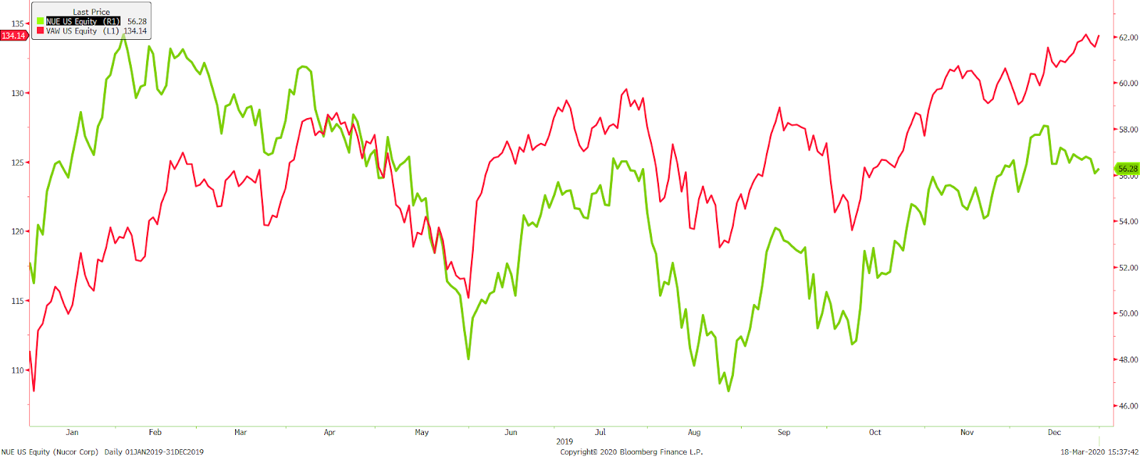
Consumer Discretionary

AMAZON.COM INC.
Ticker: AMZN
Beta: 1.57

Description
Amazon was established in July 1994 by Jeff Bezos and is headquartered in Bellevue, Washington. Amazon.com Inc provides services in online retail sales of millions of consumer products and subscription global services. Amazon has multiple sectors: resale of third-party sellers, production media content, and manufacturing sales of electronic devices. The firm’s electronic device segment includes: Kindle and Fire tablets, Fire TVs, Rings, Echo and Alexa voice capabilities. Amazon Web Services (AWS) provides storage, databases, computing, fulfillment, advertising, publishing and digital content subscriptions. Amazon’s most notable service is, Amazon Prime. Amazon Prime is described as a membership program which delivers free two-day shipping, streaming of movies and TV episodes. Amazon is an international conglomerate that continues to expand rapidly and has a market capitalization of $840.88 billion.

Performance
Amazon ended 2019 with a positive gain of 30.73% while the S&P 500 consumer discretionary index(S5cond) returned 27.94%. An improvement for Amazon was their continued shift into retail locations. Amazon, in 2019 had 479 Whole Food Markets with convenient same day Amazon pick-up, 11 Amazon Go stores, 18 Amazon Books stores, and continually growing Amazon Pop-up stores. The over 30% gain can also be contributed to Amazon’s same day grocery delivery options and available pick up options within Whole Food stores. In 2019, Amazon Prime reached over 100 million paid Prime subscribers. Alexa AI or artificial intelligent services continue to expand as well and are predicted to hit an all time number of subscribers and users within 2020.

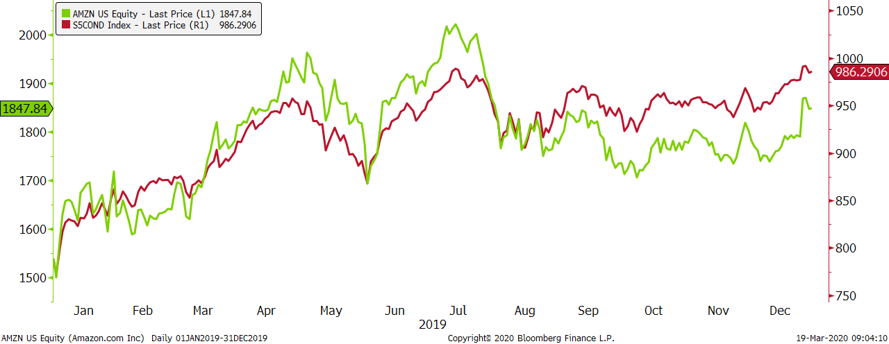
BOOKING HOLDINGS INC.
Ticker: BKNG
Beta: .96

Description
Booking Holdings was founded in 1996 by Jay Walker and is headquartered in Norwalk, Connecticut. Booking Holdings is considered the world’s largest online travel agency by revenue by offering multiple services to its worldwide clientele. Booking operates travel websites with the names, Booking.com, Priceline.com, Kayak.com, Momondo, Agoda, OpenTable.com and Rentalcars.com. These websites allow for booking for hotels, vacation rooms, flights, rental cars, restaurant reservations, cruises, experiences and multiple other vacation package options. Booking Holdings currently operates with a market capitalization of $52.96 billion.

Performance
Booking Holdings illustrated a strong recovery in 2019, producing a 19.24% yearly return. The industry saw overall increases as globally travel grew. Booking Holdings saw increased competition from Airbnb and Vrbo but was still able to perform well with these notable competitors. Most of the firm’s growth came from accommodations where rooms booked were up 12%. Booking Holding and its subsidiaries are working to integrate purchasing options. Moving into 2020, Booking Holding is hoping to expand its international business by growing bookings in this sector.

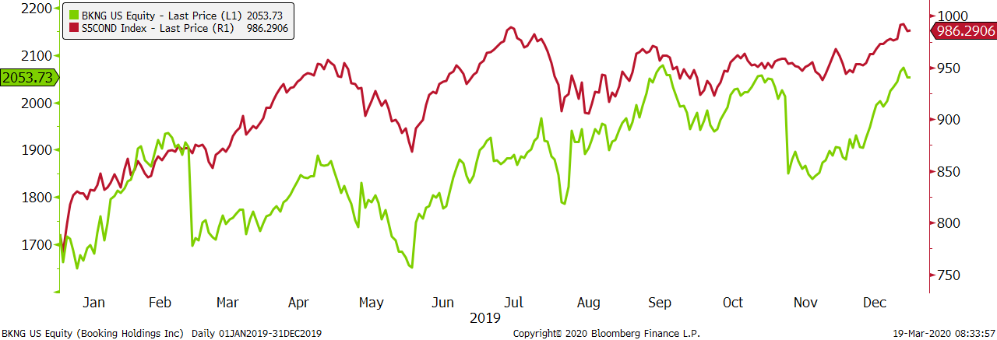

GENERAL MOTORS
Ticker: GM
Beta: 1.30

Description
General Motors was founded by William C. Durant in 1908 and is currently headquartered in Detroit, Michigan. General Motors Co works in designing, manufacturing and sales of cars, automobile parts and trucks. General Motors Financial Company Inc, a subsidiary of General Motors, provides automotive financing services. General Motors sells its cars, trucks and parts under Chevrolet, Cadillac, Baojun, Buick, GMC, Holden, Jiefand, Wuling, Maven and OnStar brands. Extending outside of auto manufacturing, GM offers services including automatic crash response, crisis assist, stolen vehicle assistance, turn by turn navigation, remote control of vehicles, on-demand vehicle diagnostics, smart driver, connected navigation, as well as 4G LTE wireless connectivity. The firm remains the market leader in the United States with 17% share in 2019. General Motors operates with a current market capitalization of $30.01 billion.

Performance
General Motors did underperform the consumer discretionary sector but had a strong return of 14.01% in 2019. Although General Motors struggled with labor strikes and closed the Lordstown plant, the announcement of the new C8 Corvette, upgrades to the Chevy Tahoe and Chevy Blazer allowed for strong growth throughout the year. Cadillac was GM’s leading electric vehicle brand. General Motors also expanded and saw growth in their China and South American sectors. Moving forward, General Motors continues to develop better energy efficient vehicles and expand upon autonomous cars.

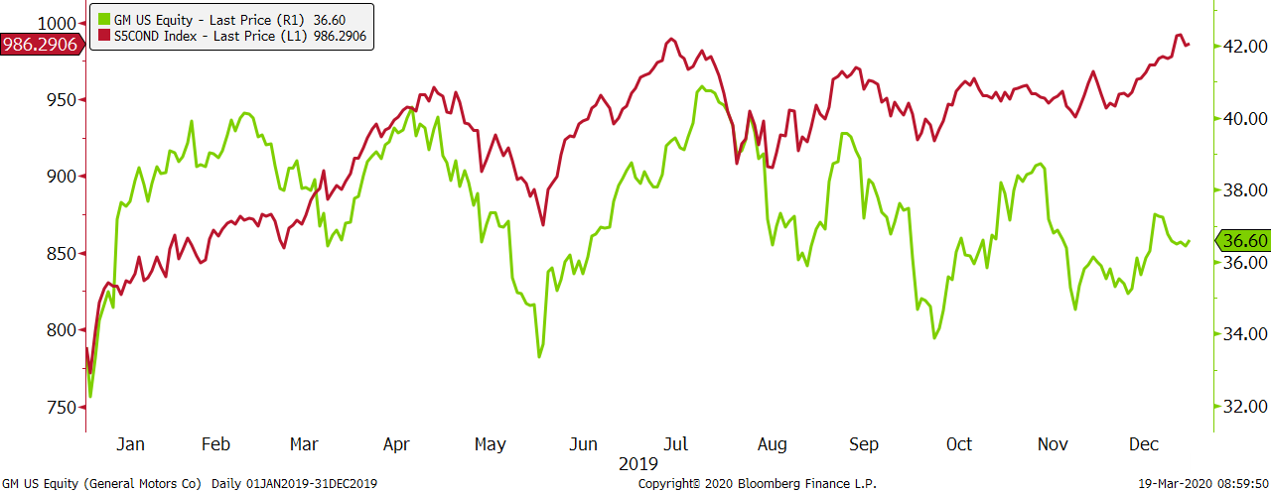

HOME DEPOT
Ticker: HD
Beta: .93

Description
Home Depot was established in 1978 by Benard Marcus, Arthur Blank, Kenneth Langone, and Pat Farrah and is headquartered in Atlanta, Georgia. Home Depot is a home improvement retailer that sells building materials, lawn and garden services, home improvement products and décor products. The three main customer sectors that Home Depot caters to are: professional contractors, do it yourself customers and do it for me customers. Home Depot operates with a market cap of $238.41 billion.

Performance
Home Depot returned 30.54% in 2019 which outperformed the industry by 2.6%. With the booming housing market across the United States, Home Depot experienced increased sales. Also, low unemployment rates allowed more citizens to purchase homes. With more homeowners, many are looking to perform do it yourself projects that led to over 50% of sales being derived from the firm’s Pro sector. Similar to other companies in the consumer discretionary sector, Home Depot integrated retail and online order. Home Depot began offering same day pick up and better delivery strategies to enhance customer satisfaction.

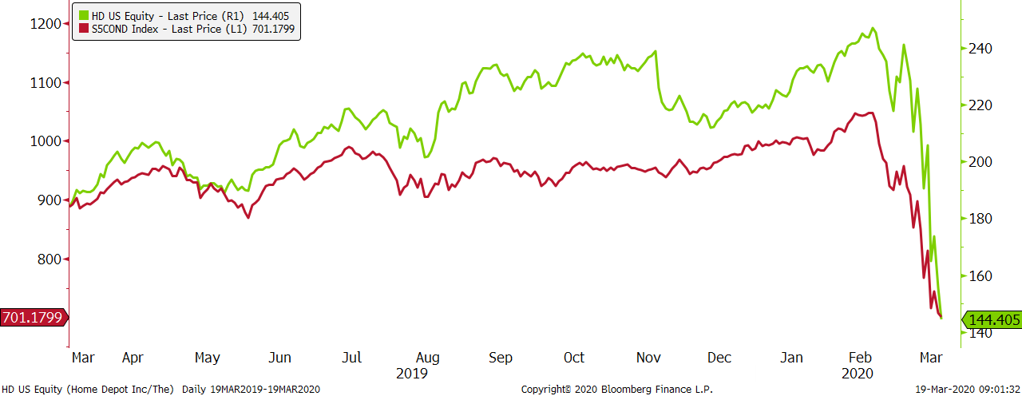

LENNAR CORP
Ticker: LEN
Beta: .99

Description
Lennar Corporation was founded in 1954 by Gene Fisher and Arnold Rosen and is currently headquartered in Miami, Florida. Lennar Corp. Is a homebuilding company that also includes real estate financial and investment management services. Lennar homebuilding includes the construction of single-family attached and detached homes, as well as the development, sale and purchase of residential land. The firm operates through: Homebuilding East, Homebuilding Central, Homebuilding Texas, Homebuilding West, Financial services, multifamily and Lennar other. Lennar Corporation operates with a market capitalization of $18.34 billion.

Performance
Lennar Corporation saw an impressive return of 42.95%, largely outperforming the consumer discretionary sector. Lennar Corporation experienced a hard 2018 due to high interest rates but saw vast improvements as home sales reached an all-time high across the nation. The firm’s revenue from home sales increased over 9% in 2019 totaling $20.6 billion. Lennar beat all estimates for earnings in 2019 and looks to continue the strong growth. In 2020, Lennar Corp is working to build more energy efficient homes starting with the inclusion of solar panels.

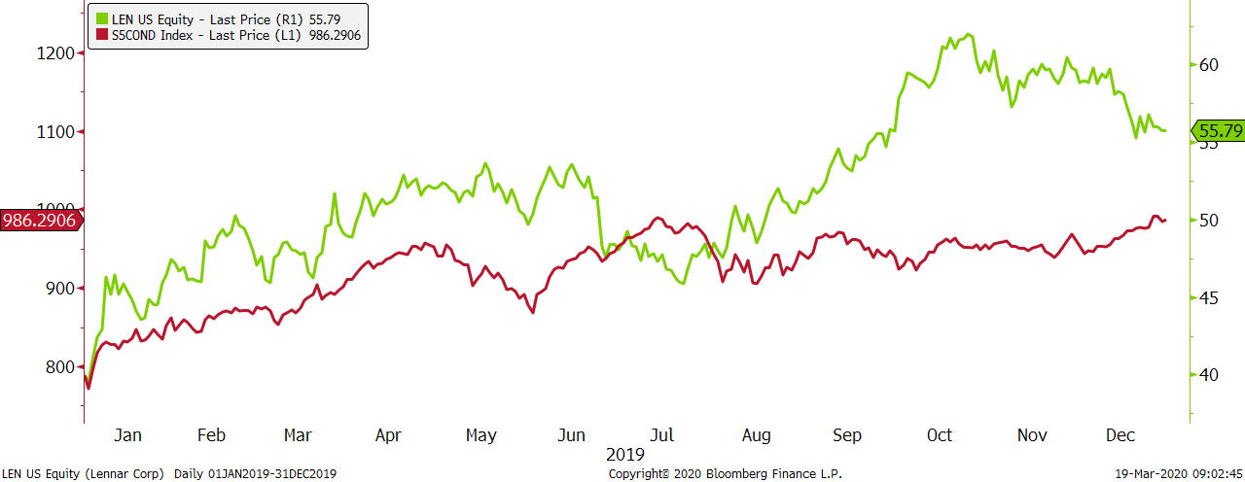

Financial

BANK OF AMERICA CORP.
Ticker: BAC
Beta: 1.18

Description
Bank of America Corporation was established in 1904 by Amadeo Peter and is headquartered in Charlotte, North Carolina. More specifically, Bank of America is a bank holding company and a financial holding company. The firm operates through multiple segments including, Consumer Banking, Global Wealth, Investment Management, Global Banking and Global markets. Through these segments, Bank of America offers services like deposits, consumer lending, sales and trading services, equity investments and expense allocation. Bank of America operates with a market capitalization of $327.73 billion.

Performance
Bank of America Corp had a strong 2019 producing a return of 40.16% which slightly under performed the S&P 500 Bank Industry group of 40.63%. Overall, Bank of America was driven by the strong bull market in 2019. The firm had a strong second quarter earning $7.4 billion and beating analyst estimates. Again, in the third quarter Bank of America beat profit estimates. The large fourth quarter increase was contributed by revenue growing to $22.5 billion. Bank of America is expected to continue to grow and post strong earnings in 2020.

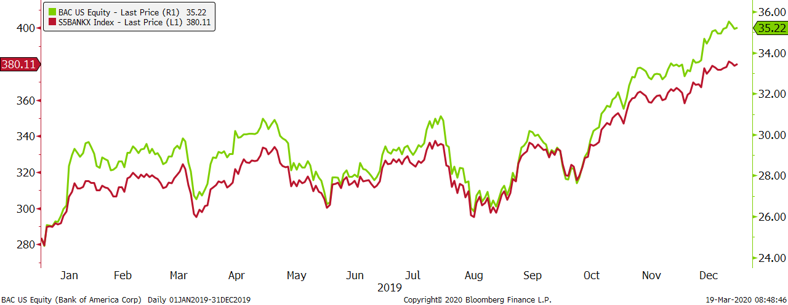

GOLDMAN SACHS GROUP INC
Ticker: GS
Beta: 1.14

Description
Goldman Sachs Group Inc has been a powerhouse on Wall Street since its inception in 1869 by Marcus Goldman and is headquartered in New York, New York. Goldman Sachs Group is an investment banking, management and securities company. The firm’s four business segments include investment banking, institutional client services, investing and lending, and investment management. Within Goldman Sachs business segments, they offer services like financial advisory services, support companies raising capital, promote buying and selling financial products, and stimulate funds and manage risk. Goldman Sachs Group operates with a market capitalization of $86.06 billion.

Performance
Goldman Sachs Group experienced a 40.46% return in 2019, tracking the S&P Bank Industry closely throughout the year. Although Goldman’s news throughout the year seemed unfortunate, the firm still produced strong earnings and revenue for the year. Goldman Sachs posted EPS of $4.79 for the third quarter, illustrating a decrease of $1.51 from 2018 and $1.03 from the second quarter. The firm also experienced a decrease in ROE of 1.4% year to date. However, Goldman Sachs noted a 20% increase on revenue from the third to fourth quarter. The firm still reported strong revenue, profit, EPS and sales throughout 2019. Overall, Goldman Sachs is in a strong financial position and is expected to see continued gains throughout 2020 as a powerhouse of Wall Street.

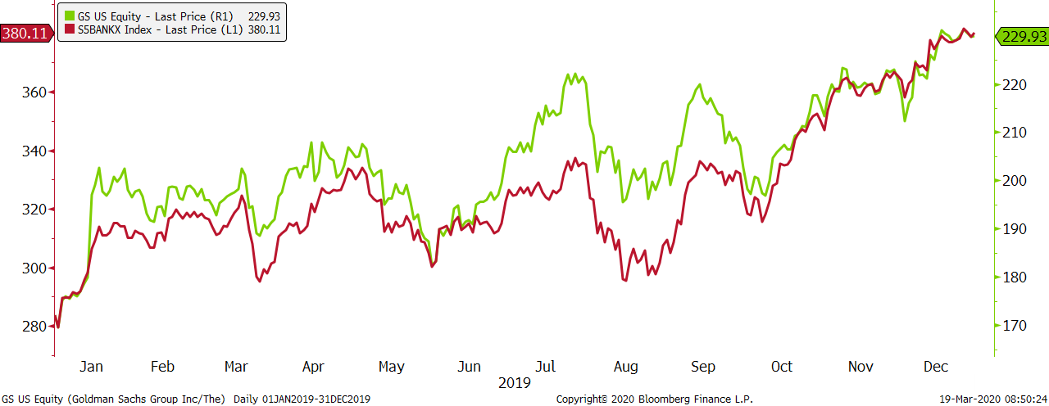

TRUIST FINANCIAL CORP
Ticker: TFC
Beta: 1.19

Description
Truist Financial Corp was established after a merger in December 2019 and is headquartered in Charlotte, North Carolina. The Bauhard Fund obtained Truist after the merger between BB&T, which was previously owned by the fund, and SunTrust Financials. Truist Financial Corp is a financial holding company that works in banking services for individuals, businesses and municipalities. Although the firm is newer, both BB&T and SunTrust have previously had very successful mergers. Currently, the market capitalization for Truist Financial is $39.3 billion.

Performance
Truist Financial Corp closely tracked the S&P bank industry closely and produced a return of 34.52% in 2019. As a new firm this year, Truist had a strong fourth quarter with revenue totaling $3.7 billion. Both BB&T and SunTrust had strong first and second quarters in 2019 that allowed for strong continued growth after their merger in December. Moving into the next fiscal year, Truist is expected to see growth in revenue, EPS and reduce overall expenses.

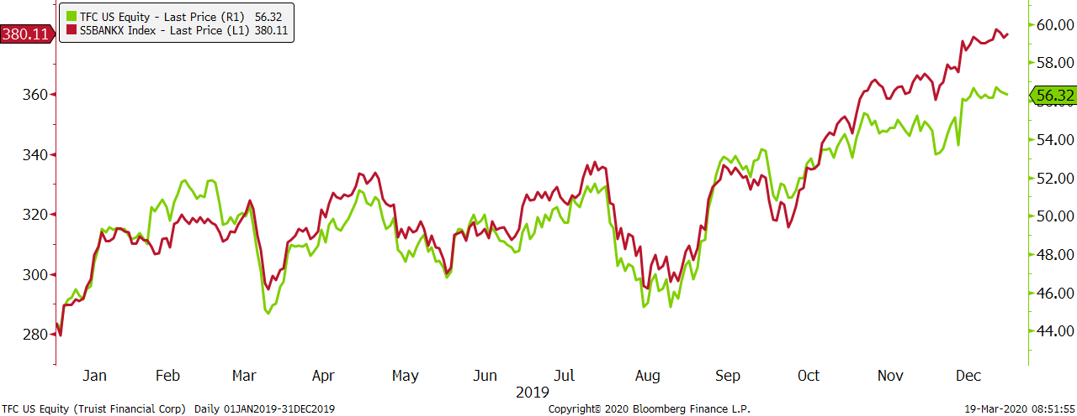

Healthcare

ABBOTT LABORATORIES
Ticker: ABT
Beta: .93

Description
Abbott Laboratories was founded in 1888 in Chicago, Illinois by Wallace Calvin Abbott, and is currently headquartered in Lake Buff, Illinois. Abbott Laboratories develops, sells, and manufactures a large line of healthcare related products, which include Pedialyte, Ensure, and blood glucose monitors. Abbott operates in approximately 92 manufacturing facilities around the world, 30% of those facilities are used for pharmaceutical products, 25% diagnostic products, and 29% medical devices. The remaining 16% is made up of nutritional products. The United States accounted for nearly 36% of sales for Abbott in 2019. Abbott is currently headquartered in Lake Buff, Illinois, and has a market capitalization of $153.09 billion.

Performance
Abbott Laboratories ended the year 2019 with a return of 27.07% while the Vanguard Health Care ETF returned 23.51% in 2019. The positive return for Abbott can be attributed to increased sales of the FreeStyle Libre blood glucose monitor. The Freestyle Libre had an increase of 69.8%, or $1.84 billion compared to 2018 sales. Abbott also saw strong growth in their electrophysiology sector with improvements in catheters, increasing sales around the globe. Revenue in the heart failure sector of Abbott was primarily driven by quick adoption of the HeartMate 3 in the United States. Abbott Laboratories plans on growing their established pharmaceuticals, medical devices, and laboratory diagnostics in 2020 to further increase revenue and gross margin.

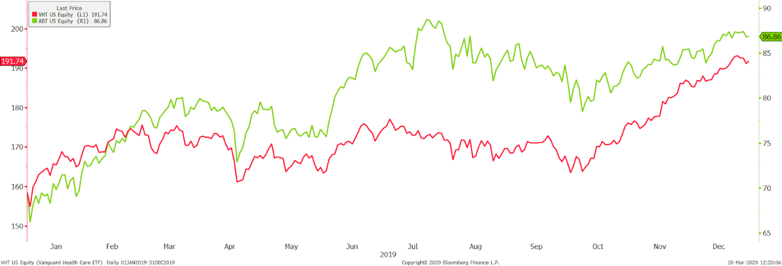

BRISTOL-MYERS SQUIBB
Ticker: BMY
Beta: .87

Description
Squibb Company was founded in 1858 by Dr. Edward Squibb in New York City, and evolved into Bristol-Myers Squibb in 1887. The company is currently headquartered in New York City. Bristol-Myers Squibb is a biopharmaceutical company that develops, manufactures, and sells pharmaceutical products. Products from Bristol-Myers include medications for diabetes, cancer treatment, heart disease, and HIV/AIDS. Bristol-Myers Squibb aims to promote healthy lifestyles and improve the lives of their patients around the world. Bristol-Myers Squibb operates with a current market capitalization of $110.64 billion.

Performance
Bristol-Myers Squibb showed strong growth in 2019, providing a 26.77% return for the year. BMY outperformed the comparison ETF of Vanguard Healthcare by 3.26% for the year. One of the main factors that helped Bristol-Myers prosper in 2019 was it’s oncology drug, Opdivo. This medication is used to treat those with advanced lung cancer. The company reported over $5 billion dollars before the end of the third quarter 2019 of this new drug. The acquisition of Celgene Corporation allowed Bristol-Myers to add oncology and anemia drugs to its product line and boosted sales for 2019. BMY plans on further expanding its oncology and diabetes drugs in 2020.

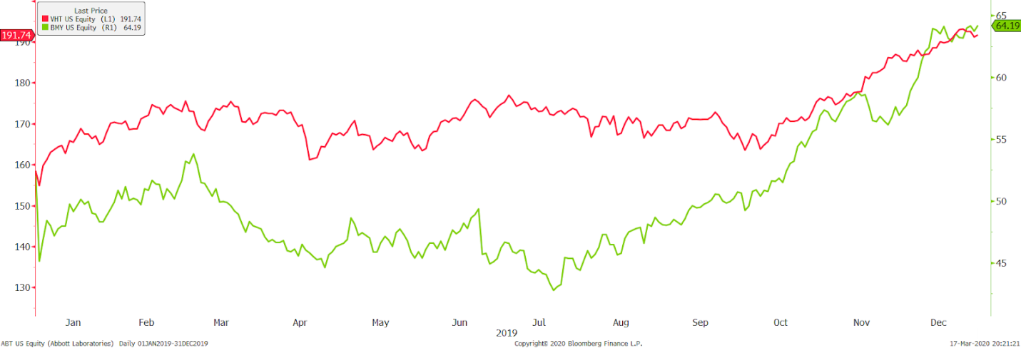

CVS HEALTH
Ticker: CVS
Beta: 1.15

Description
Consumer Value Stores, better known as CVS, was founded in 1963 by Ralph Hoagland, Stanley Goldstein, and Sidney Goldstein. The company was later purchased by Melville Corporation in 1969. After years of product development and expansion, CVS established itself as a household name. CVS Corporation became a standalone company due to restructuring within Melville Corporation in 1996 and began trading on the New York Stock Exchange. The company is headquartered in Woonsocket, Rhode Island. The company currently operates under the segments of pharmacy, long term care, and retail, and has a market capitalization of $76.40 billion.

Performance
CVS provided a return of 17.16% in 2019, falling 6.35% below the Vanguard Health Care comparison ETF. Factors that play a role in the lower return include higher costs for the pharmaceutical companies due to availability of generic drugs and weak retail sales for the year. CVS is paying their long-term debt which was added with the acquisition of Aetna, a health care and insurance company. Updates to the existing CVS stores also contribute to the lower return for 2019. The top two points of focus for CVS moving into 2020 are digital healthcare and advancing practices related to kidney care.

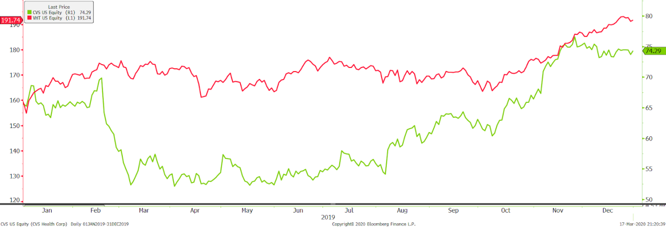
GILEAD SCIENCES
Ticker: GILD
Beta: .92

Description
Gilead Sciences was founded in 1987 by Michael Riordan and is currently headquartered in Foster City, California. Gilead operates in the biopharmaceutical industry and the company's main focus is developing and commercializing antiviral drugs. Acquisitions have been a large part of Gilead's business structure since 2002 with their acquisition of Triangle Pharmaceuticals. The acquisition strategy has allowed Gilead to develop and commercialize drugs through a broader range of health care segments such as oncology and cardiovascular. Gilead currently has a market capitalization of $104.84 billion.

Performance
Gilead Sciences generated a return of 6.37% for 2019, while the comparison ETF of Vanguard Health Care returned 23.51%. The weak return for Gilead can be attributed to a large increase in research and development expenses. R&D expenses were $9.1 billion in 2019, up from $5.0 billion in 2018. The increase in expense comes from a partnership with Galapagos, a European Pharmaceutical company. Net income was also down from $5.5 billion in 2018, to $5.4 billion in 2019. Gilead expects to deliver new and innovative drugs to their patients in 2020, including cardiopulmonary and cell therapy.

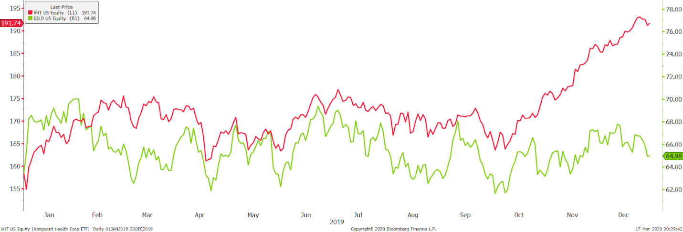

MERCK & CO
Ticker: MRK
Beta: .78

Description
Merck & Co was founded in 1891 by George Merck and is currently headquartered in Kenilworth, New Jersey. The company develops and manufactures prescriptions, vaccines, and healthy living products for animals. Merck & Co is composed of four different operating segments: Healthcare Services, Pharmaceutical, Alliances, and Animal Health. Merck & Co generates revenue from selling medications to retail drug stores, hospitals, and drug wholesalers. Merck has a market capitalization of $176.80 billion.

Performance
Merck & Co generated a 23.59% return for 2019, up .08% compared to the Vanguard Health Care ETF. The positive return for the year can be attributed to Merck’s 11% increase in sales from 2018, driven by developments in cancer treating medication and FDA approval on new medications. Merck is expecting strong revenue growth with FDA approvals of new medications for 2020.

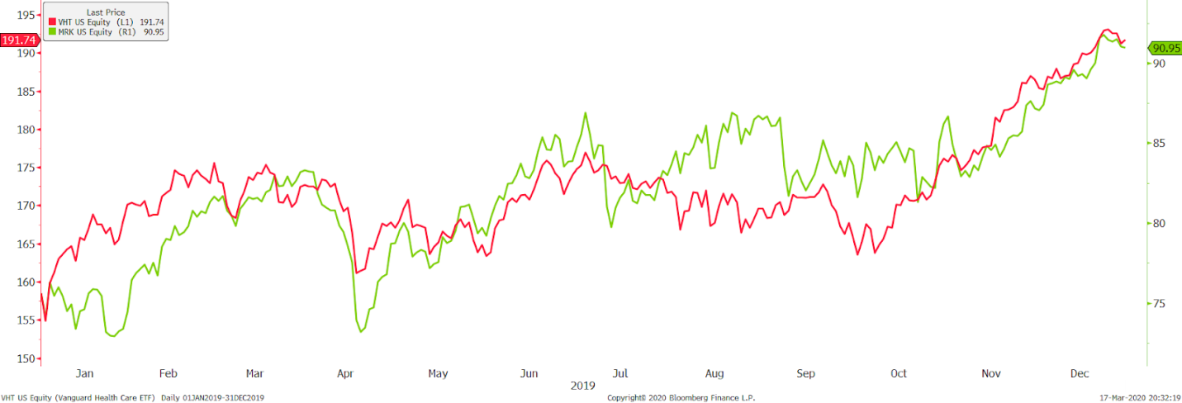

Industrials

3M
Ticker: MMM
Beta: .98

Description
3M was founded in 1902 by John Dwan, Hermon Cable, William McDonagle, and Henry Bryan. The company is currently headquartered in Maplewood, Minnesota. 3M operates in many segments including industrials, health care, automotive, and safety products. Products from 3M include adhesives, safety masks, reflective lining, medical and car products. 3M is a global company that does business in over 60 countries. 3M has a market capitalization of $77.91 billion.

Performance
3M saw a -4.26% return for 2019, compared to a 29.54% return for the Vanguard Industrial ETF. The negative return for the year can be attributed to a dust mask lawsuit which cost 3M $762 million, an increase in cost of sales, as well a decline in net sales from 2018-2019. Forward looking, 3M wants to move to 100% renewable energy.

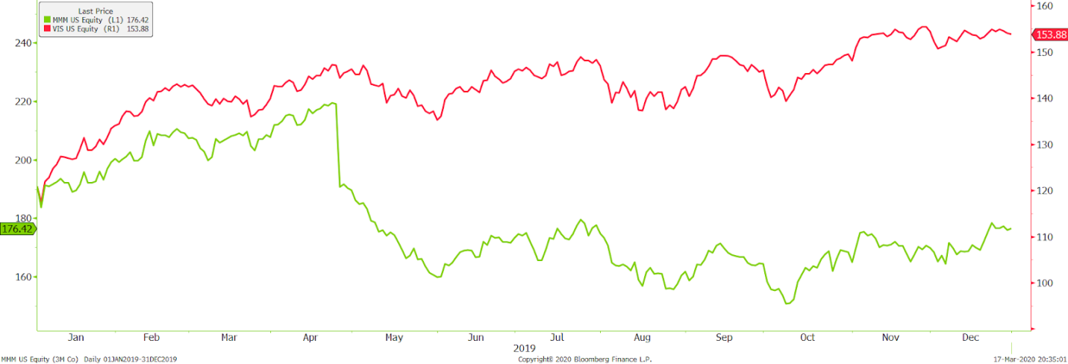

HONEYWELL
Ticker: HON
Beta: .97

Description
Honeywell was founded in 1906 by Mark Honeywell in Wabash, Indiana and is currently headquartered in Charlotte, North Carolina. Honeywell specializes in technology and manufacturing. The company operates within four main business segments which include Home and Building, Aerospace, Performance Materials, and Safety. Honeywell offers a diverse product line, which includes software, as well as hard product such as thermostats and humidifiers. Honeywell operates in 70 countries and employs over 100,000 people across the globe. Honeywell has a market capitalization of $82.41 billion.

Performance
Honeywell generated a 37.02% return for 2019. This is 7.48% higher than the comparison Vanguard Industrials ETF. Honeywell had an increase in sales of 14% in the Defense and Space business segment, primarily driven by an expansion of international and domestic defense systems. The company also experienced an increase in sales from 2018-2019 in Performance Materials and Technology.

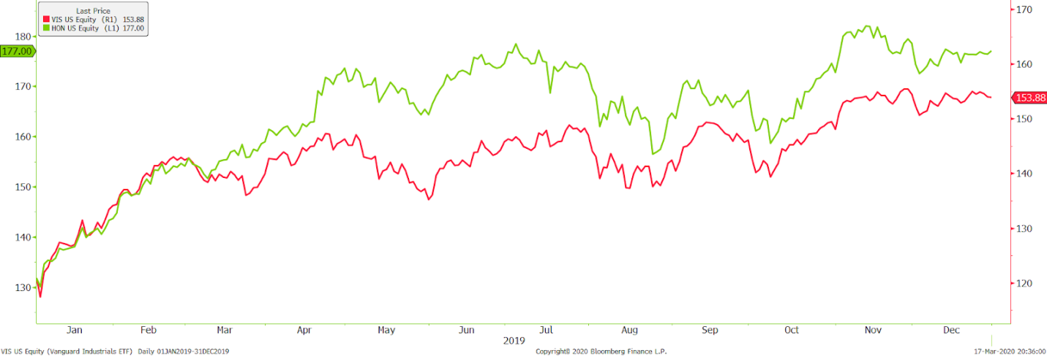
UNION PACIFIC
Ticker: UNP
Beta: 1.04

Description
Union Pacific was founded in 1862, and is currently headquartered in Omaha, Nebraska. The Union Pacific Railroad is the second largest rail system in the United States, with a rail track extending over 32,000 miles. UNP offers the safest rail transportation of products around the United States and employs 42,000 people. Union Pacific has a market capitalization of $82.31 billion.

Performance
Union Pacific experienced strong growth in 2019, returning 34.11%, 9.57% higher than the comparison ETF of Vanguard Industrials. UNP reported an increase in sales of 2% in the industrial freight revenues, as well as an operating expense decline of $1.20 billion from 2018. Equipment rent also decreased 8% due to improvements in operations. Looking forward into 2020, Union Pacific anticipates reaching its goal set by their “Unified Plan 2020” which strives to reach a 60% operating ratio by the end of the year. Union Pacific did follow the trendline of the comparison ETF throughout 2019.

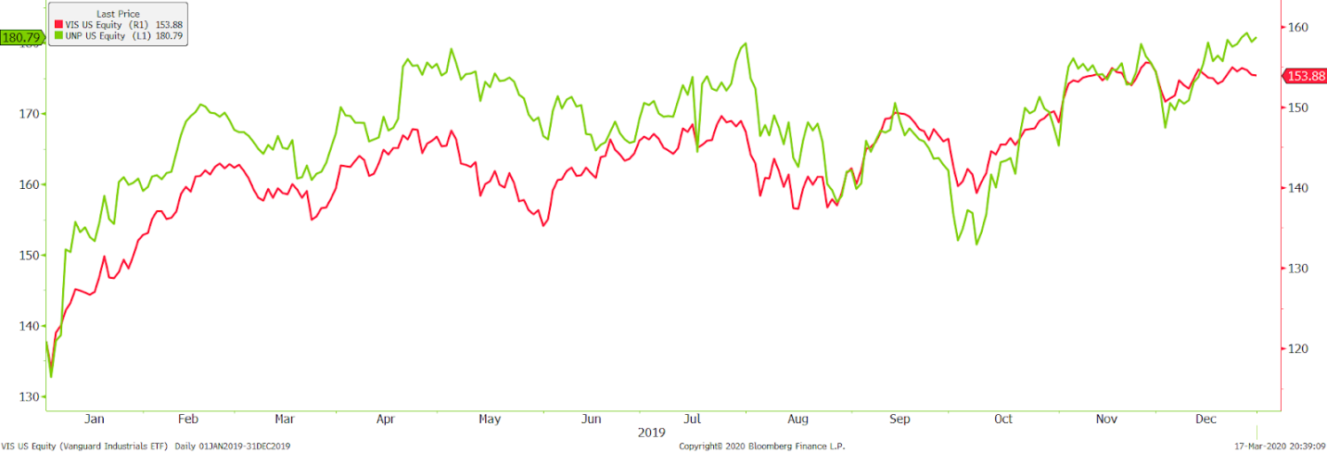

UNITED TECHNOLOGIES
Ticker: UTX
Beta: 1.10

Description
United Technologies was founded in 1934 by Frederick Rentscler and is currently headquartered in Farmington, Connecticut. United Technologies offers products in the building systems and aircraft industry, such as engines and security systems. The company strives to integrate the safest and newest technology into their products. UTX generates most of its revenue from the aerospace segment of their business operations, with products such as HVAC systems, computers, and safety monitors. United Technologies has a market capitalization of $70.25 billion.

Performance
United Technologies returned 41.39% in 2019, falling short of the comparison ETF of Vanguard Information Technology by 7.13%. United Technologies acquired Raytheon, a defense agency, which helped boost earnings for UTX. Overall, UTX followed the trendlines of the ETF over the course of 2019, although it underperformed the ETF overall. Cost of goods did rise during the year, mainly due to increased research and development costs which are included in cost of goods.

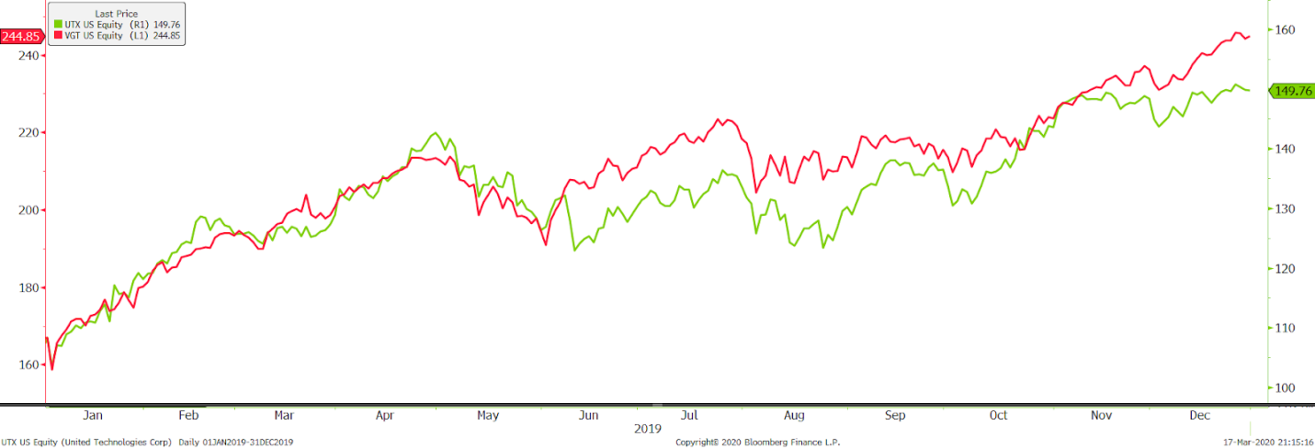

Real Estate

PUBLIC STORAGE
Ticker: PSA
Beta: 0.19

Description
Public Storage, headquartered in Glendale, California, is an international self-storage company that is run as a Real Estate Investment Trust. The Trust's business activities involve the acquisition, development, ownership, and operation of self-storage facilities in the United States. The company also owns an equity interest as an owner and operator of self-storage facilities in Europe and Canada, having more than 2,200 locations worldwide. Public Storage currently operates with a market capitalization of $33.17 billion

Performance
Public Storage ended 2019 with a small return of 8.97% while the S&P 500 real estate index (S5rlst) returned 29.01%. This was a year of growth in terms of net operating income and revenue. The lower increase in value comes from missing earnings estimates and facing increasing costs of operation for the company. Public Storage is comfortable entering 2020, knowing the company has well-located properties, a proven business model, and an experienced team.

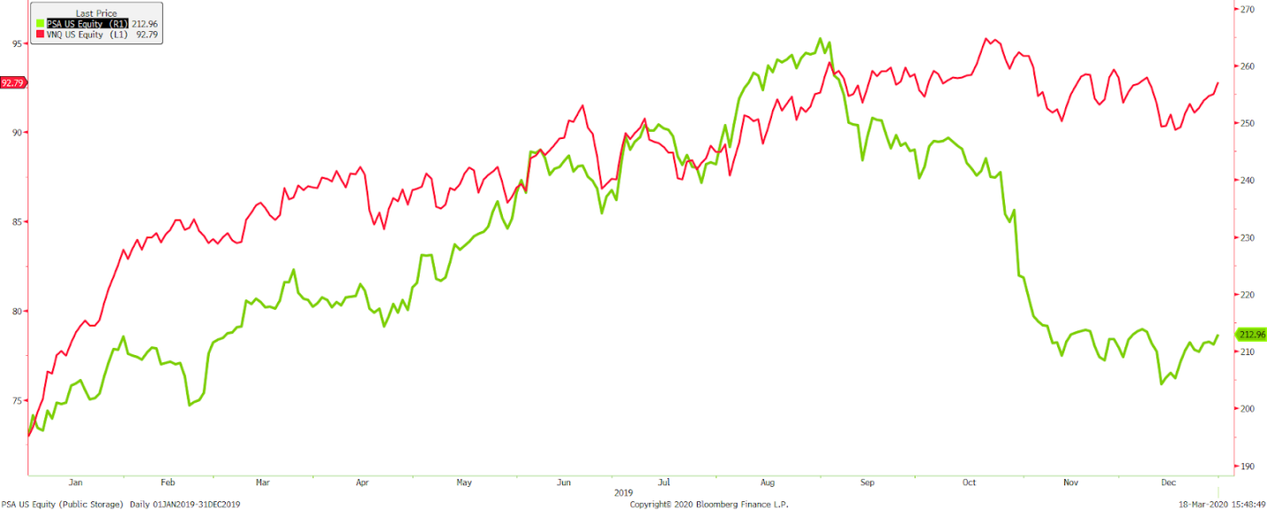

Information Technologies

ADOBE
Ticker: ADBE
Beta: .94

Description
Adobe was founded in 1982 by John Warnock and Charles Geschke and is currently headquartered in San Jose, California. Adobe is a leading computer software and technology company. Products from Adobe include design software, servers, and web design. Digital marketing remains the biggest focus for Adobe, and this will continue to be true into the upcoming years. Adobe employs over 20,000 employees globally. Adobe has a market capitalization of $148.17 million.

Performance
Adobe finished 2019 with a 46.86% return, while the comparison ETF of Vanguard Information Technology finished 1.66% higher. Adobe’s steller return for 2019 can be explained by a 31% increase in revenue for the Digital Experience segment, which is partially made up of subscription revenue. Digital Experience revenue rose from $2.44 billion in 2018, to $3.21 billion in 2019. Looking forward into 2020, Adobe anticipates that their cloud software and technology will be a primary driver for growth for the company. Adobe also looks to continue partnerships with other software and technology companies, such as Microsoft in the upcoming years.

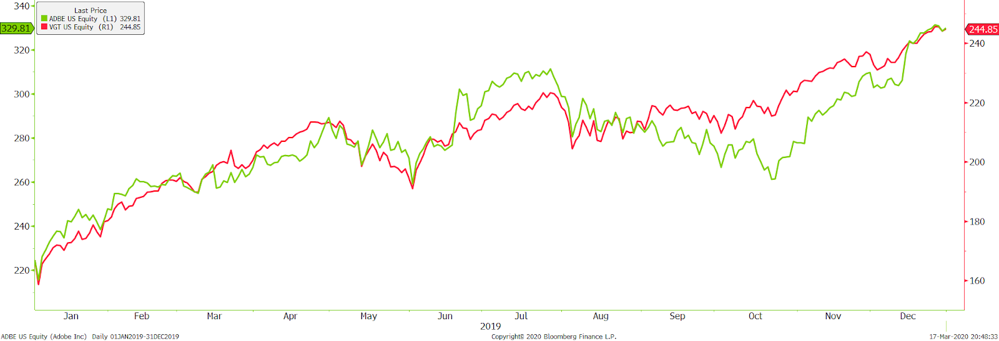

APPLE
Ticker: AAPL
Beta: 1.03

Description
Apple was founded in 1976 by Steve Jobs, Steve Wozniak, and Ronald Wayne and is currently headquartered in Cupertino, California. Apple has been a worldwide leader in computer software, hardware, and mobile technology. Apple is best known for its original apple desktop computers, iPhones, iMac laptops. Apple also uses its own software to run these devices, which has been known to be extremely user friendly. The company employs over 120,000 people worldwide and also has retail stores in the United States, United Kingdom, China, and many other countries. Apple has a market capitalization of $1.08 trillion.

Performance
Apple, the Bauhard Fund’s third top performer, finished 2019 with a 88.97% return, beating the comparison ETF of Vanguard Information Technology by 40.45%. Apple followed the trendlines of the ETF consistently through 2019 until September. Apple released their new line of product which included the iPhone 11, iPhone 11 Pro, iWatch Series 5, and the new iPad. In 2019, Apple reached its highest Q4 earnings in company history, which was driven by the products listed above. Quarterly revenue was $64 billion for Q4 2019, rising 2% from Q4 2018. Apple continues to show strong growth year-over-year due to their new and innovative technology.

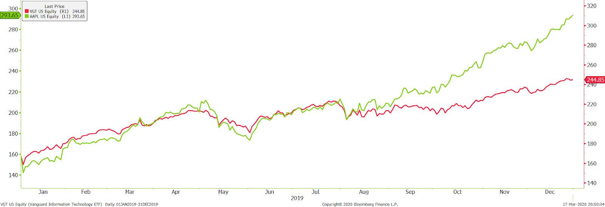

APPLIED MATERIALS INC.
Ticker: AMAT
Beta: 1.45

Description
Applied Materials, Inc was founded November 10, 1967 and is headquartered in Santa Clara, California. The company develops, manufactures, markets, and services semiconductor wafer fabrication equipment for the worldwide semiconductor industry. The company's primary customers are semiconductor wafer and integrated circuit manufacturers, as well as flat panel liquid crystal displays, solar photovoltaic cells and modules and other electronic devices manufacturers. Applied Materials Inc. currently operates with a market capitalization of $35.98 billion.

Performance
With a strong year in 2019, Applied Materials Inc. finished with a positive gain of 89.88%, the third best in the portfolio, outpacing the S&P 500 info tech index (S5inft) return of 50.29%. This substantial increase is due in part to a large increase in the demand for semiconductor equipment. The semiconductor industry looks to continue growing by improving chip performance, power, size, and cost, while continuing to find solutions in this big data era.

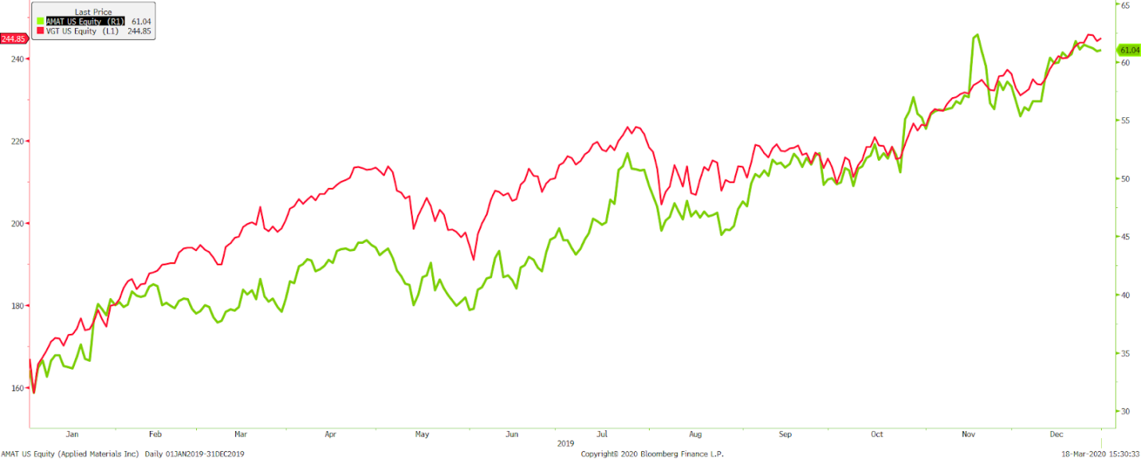

INTERNATIONAL BUSINESS MACHINES CORP.
Ticker: IBM
Beta: 1.31

Description
IBM was founded as the Computing-Tabulating-Recording Company in 1911, before changing into International Business Machines in 1924. IBM is currently headquartered in Armonk, New York. IBM is a worldwide computer solution company and offers applications, technology consulting and support, process design and operations, cloud, digital workplace, and network services, as well as business resiliency, strategy, and design solutions. IBM currently operates with a market capitalization of $91.99 billion

Performance
IBM had a solid year in 2019 with a positive return of 21.92% but was outperformed by the S&P 500 info tech index (S5inft) by 28.37%. Since 2012, IBM has been focusing on developing new capabilities, investing more than $120 billion transforming their strategy, building a cloud and increasing research. In 2019, IBM led the U.S. in patents with 9,262, while en route to entering the hybrid cloud market.

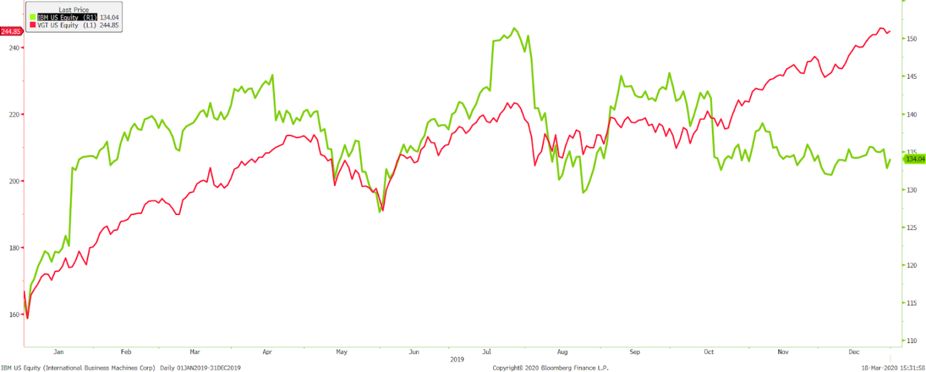

LAM RESEARCH CORP.
Ticker: LRCX
Beta: 1.49

Description
Lam Research Corporation is a worldwide semiconductor company, founded in 1980 and headquartered in Fremont, California. The company manufactures, markets, and services semiconductor processing equipment used in the making of integrated circuits. These products are used to deposit special films on a silicon wafer and etch away portions of various films to create a circuit design. Lam Research currently operates with a market capitalization of $28.26 billion.

Performance
Lam Research ended the 2019 as the second-best performer in the portfolio, having a positive gain of 119.31% and outperforming the S&P 500 info tech index (S5inft) by 69.02%. In the 2019 fiscal year, Lam Research’s revenues totaled $9.7 billion and the company’s cash flow from operations reached a record of $3.2 billion. These results are linked to the value delivered and services provided. The 5G evolution in wireless communication is helping to increase the value, as this emerging area will increase the need for advancements in semiconductor computing powers.

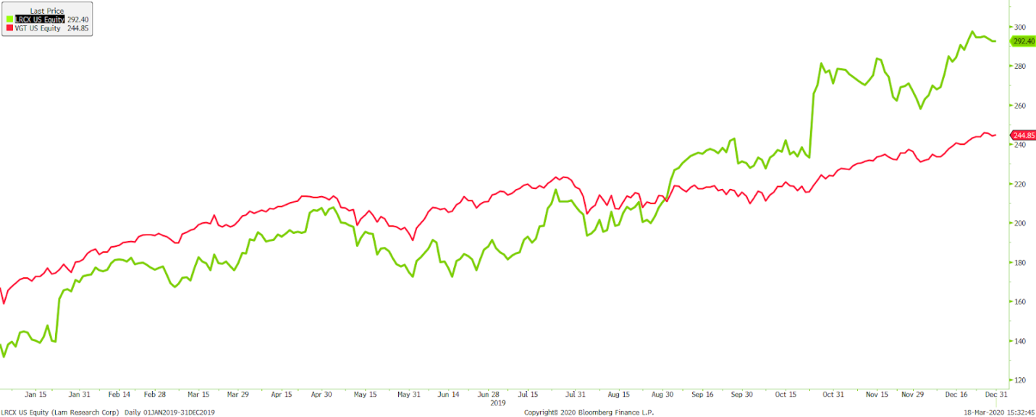

PAYPAL HOLDINGS INC.
Ticker: PYPL
Beta: 0.92

Description
PayPal Holding, Inc. was founded in 1998 and has headquarters in San Jose, California with 21,000 employees. The company. operates worldwide as a technology platform company, enabling digital and mobile payments on behalf of consumers and merchants. The company offers online payment solutions. PayPal currently operates with a market capitalization of $107.28 billion.

Performance
PayPal ended 2019 with a nice, positive gain of 26.15%, but when compared to the S&P 500 info tech index (S5inft), PayPal underperformed by 24.14%. In 2019, PayPal set records for revenue, net income, and operating margin, while also adding 37 million net new active accounts and processing $712 billion in total payments. In November, PayPal acquired the growing Honey Science Corporation for approximately $4 billion, hoping to increase sales and customer engagements.

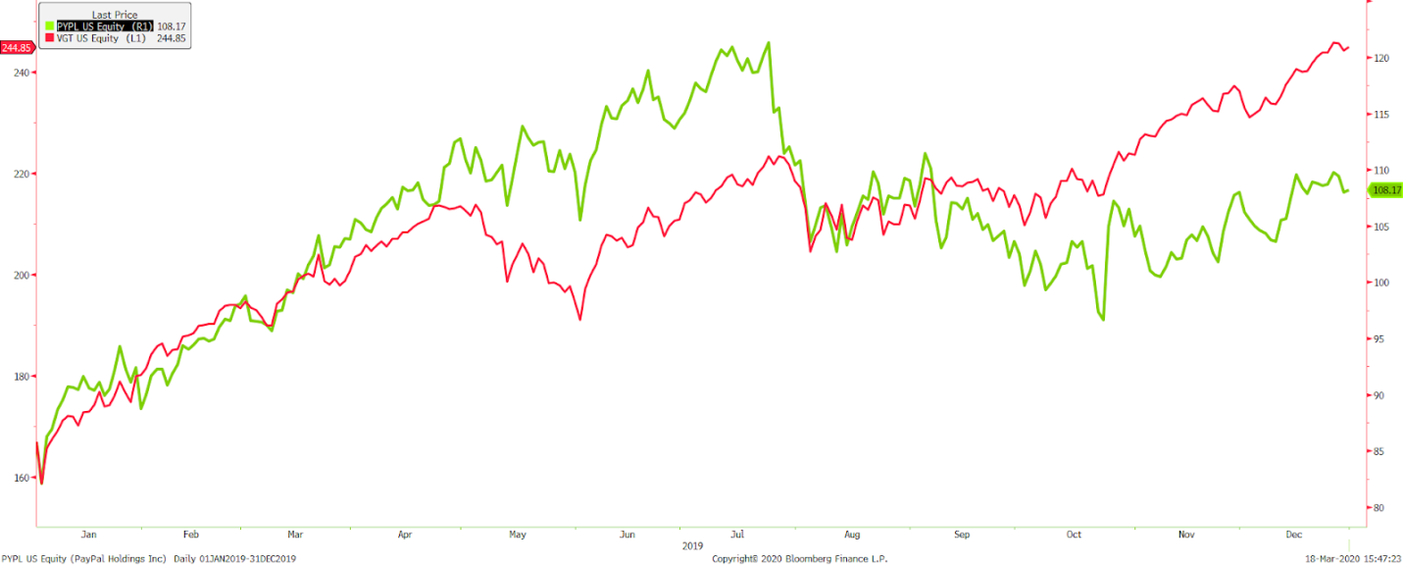

SALESFORCE.COM INC.
Ticker: CRM
Beta: 1.22

Description
Salesforce.com, Inc. is a cloud-based software company that designs and develops enterprise software. The company was founded in 1999 and is headquartered in San Francisco, California. Salesforce.com supplies a customer relationship management service to businesses worldwide, providing a platform for customers and developers to build and run business applications. These applications are used to manage customer, sales, and operational data. Salesforce.com currently operates with a market capitalization of $118.35 billion.

Performance
Salesforce.com ended 2019 with a positive gain of 18.74% but underperformed when compared to the S&P 500 Info Tech index (S5inft) by 12.74%. This underperformance is attributed to increased competition coming from many large companies, including Adobe, Microsoft, and Oracle. Salesforce’s focus in 2019 was to continue to strengthen their relationships with other companies of all sizes. In doing so, the company furthered their relationship with both Google and Amazon Web Services while also forming a new partnership with Apple.

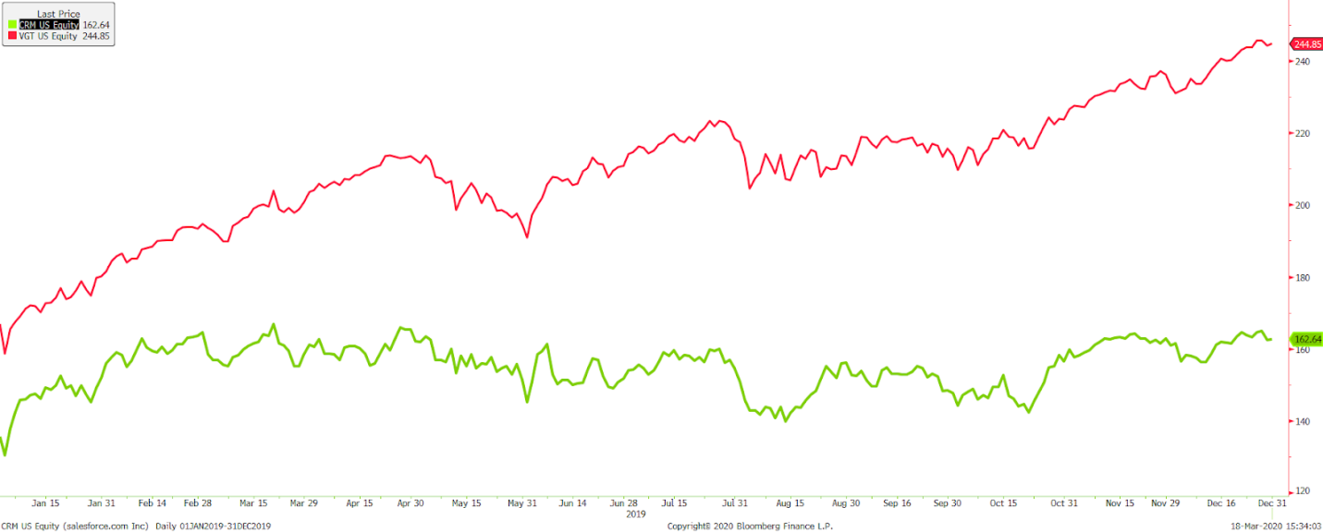

SOLAREDGE TECHNOLOGIES INC.
Ticker: SEDG
Beta: -0.24

Description
SolarEdge Technologies Inc. provides solar power optimization and photovoltaic monitoring solutions. The company was founded in 2006, with offices in Germany, Italy, Israel, Japan, and the U.S. while serving worldwide. SolarEdge creates optimizers, inverters, monitoring equipment, tools, and accessories for power harvesting, conversion, and efficiency. SolarEdge Technologies currently operates with a market capitalization of $377.8 million.

Performance
SolarEdge Technologies was the portfolio's top performer in 2019. SEDG finished the year with a positive return of 170.91%, outperforming the S&P 400 Information Technology sector (S4inft) by 128%. Last year was a tremendous year for SolarEdge, not only setting company records, but also expanding the company. The company set a record for revenue of $1.4 billion, with $1.3 billion of that coming from solar products, up 46% year over year. SolarEdge gained certification from Japan Electrical Safety and Environment Technologies Laboratory and has manufacturing expansion underway in Hungary and Vietnam.

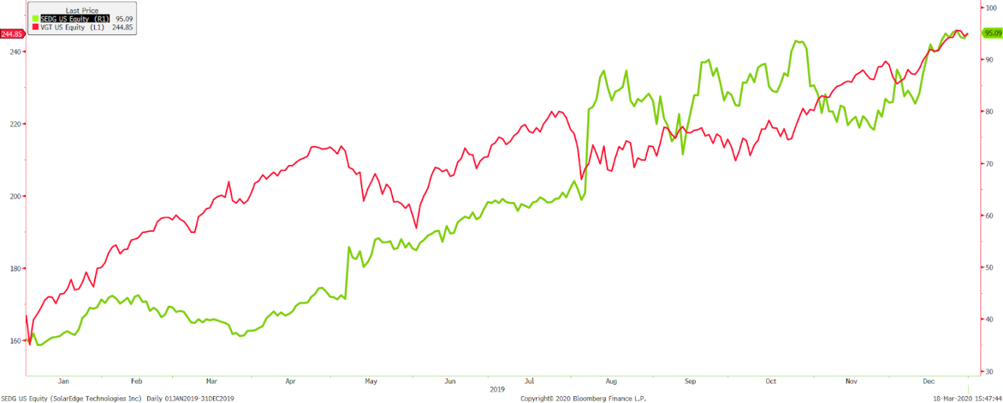

VISA INC.
Ticker: V
Beta: 0.93

Description
Visa Inc. was founded in 2007 and operates as an electronic payments network for retailers and manages global financial services. The company also offers global commerce through the transfer of value and information between financial institutions, merchants, consumers, businesses, and government entities. Visa currently operates with a market capitalization of $297.39 billion.

Performance
Visa ended the 2019 year with a positive gain of 43.32%, just 6.97% below the S&P 500 Info Tech index (S5inft). Visa made great progress helping grow digital payments globally in 2019. The company did this by growing the core business, expanding partnerships, and creating new payment flows. To help the core business, Visa expanded on Tap to Pay and Ecommerce. The company introduced Visa Fintech Fast as a way to provide new partners tools to increase connections, while still maintaining traditional relationships with companies like Bank of America, BBVA, and J.P. Morgan Chase. Along with improving former implementations, Visa also introduced Visa Direct and Earthport, creating new networks.

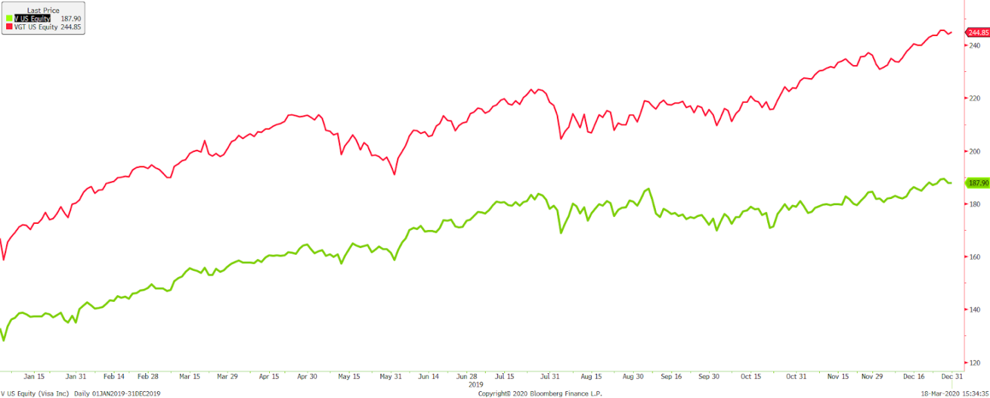

Consumer Staples

ARCHER DANIEL MIDLAND CO
Ticker: ADM
Beta: .978

Description
Archer Daniel Midland Co was founded in 1902 and is currently headquartered in Chicago, Illinois. Archer Daniel Midland processes oilseeds, wheat, corn, cocoa and other agricultural commodities. The firm manufactures protein meal, vegetable oil, corn sweeteners, flour, biodiesel, ethanol and other feed and food ingredients. Archer Daniels Midland Co includes three sectors of operation which are: agricultural services and oilseeds, carbohydrates solutions and nutrition. The firm works domestically and globally through transportation networks and port operations. Archer Daniel Midland Co has a market capitalization of $25.43 billion.

Performance
Archer Daniels Midland Co returned 17.08% in 2019 but did not match the Consumer Staples Select sector SPDR which returned 27.43% over 2019. Archer Daniels experienced steep decreases in June due specifically to an E. coli outbreak that required the firm to recall much of their flour distribution. The trade wars with China also greatly affected Archer Daniels global shipping and transportation operations which overall affected their yearly return. Archer Daniels began to see strong growth and return by the end of 2019.

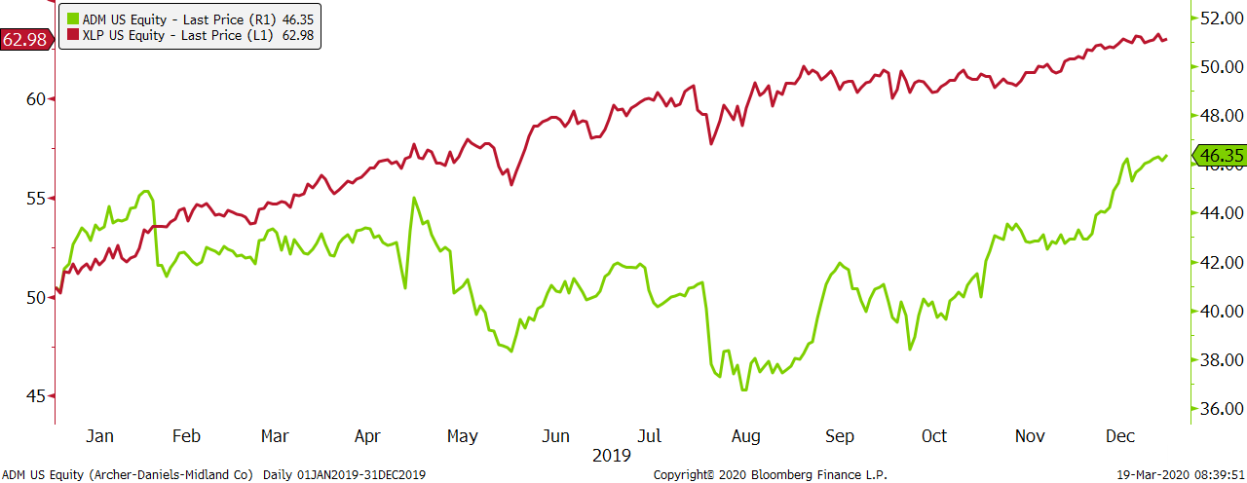

PEPSICO INC.
Ticker: PEP
Beta: .78

Description
PepsiCo Inc was founded in 1965 by Donald Kendall and Herman Lay and is headquartered in Purchase, New York. PepsiCo is a global food and beverage company that includes brands like Frito-Lay, Gatorade, Pepsi-Cola, Quaker and Tropicana. The firm is a global powerhouse that includes beverages and food to North America, Latin America, Europe Sub-Saharan Africa, Asia, and Middle East and North Africa. PepsiCo Inc operates with a market capitalization of $189.75 billion.

Performance
PepsiCo produced a return in 2019 of 27.37% just under the Consumer Staples Sector by less than .05%. However, PepsiCo performed extremely well in the last two quarters of the year. PepsiCo sponsoring both the NFL and the Super Bowl, combined with ingenious advertisements, brought strong revenue growth in the second half of 2019. Pepsi worked to transform the soda industry by introducing its “Pepsi Nitro” in early 2019 and expecting to see sales increase in 2020. Ramon Laguarta became the new CEO of Pepsi in early 2019 and announced the restructuring of plants and some layoffs in order to save $1 billion annually. In 2020, Pepsi will continue its focus on recycling programs and anti-plastic measures.

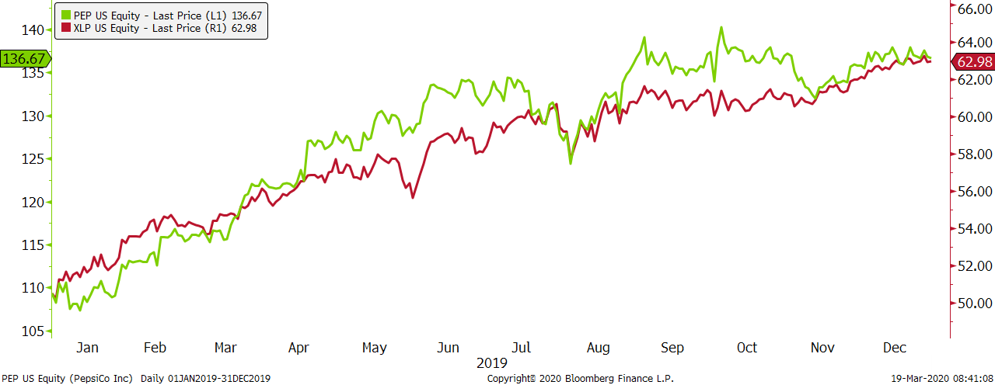

PROCTOR & GAMBLE CO
Ticker: PG
Beta: .79

Description
Proctor & Gamble Co is a long-recognized brand, established in 1837 by William Proctor and James Gamble. The firm is currently headquartered in Cincinnati, Ohio. Proctor and Gamble operates and distributes its products in five divisions: Beauty, Grooming, Health Care, Fabric and Home Care, Feminine and Family Care. Brands that PG distributes are Olay, Old Spice, Safeguard, Head & Shoulders, Pantene Mach3, Dawn, Febreze and many others. Proctor & Gamble distributes to approximately 180 countries and has a market capitalization of $313.59 billion.

Performance
Proctor and Gamble Co strongly outperformed the industry by having a return of 39.70% in 2019, while the Consumer Staples sector returned 27.43%. In the second quarter of 2019, PG was able to report the strongest quarter of organic sales growth in over a decade. Throughout the year, Proctor and Gamble worked consciously to reduce plastic waste and test new methods for distributing their products. The firm works tirelessly throughout the community to improve varying situations for children, adults and the elderly. P&G has strong brand recognition and performed exceedingly well in 2019.

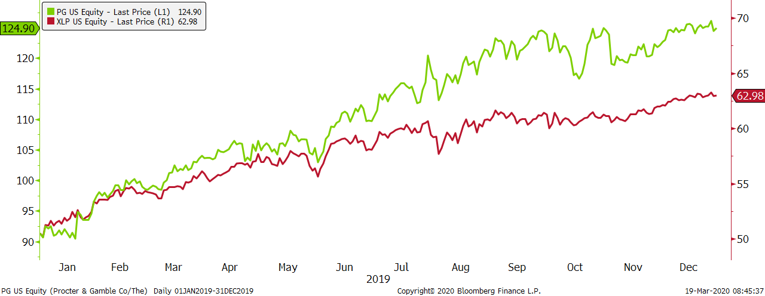

Energy

EXXON MOBILE CORP.
Ticker: XOM
Beta: 1.15

Description
Exxon Mobil Corporation was founded by John. D. Rockefeller in 1882 and is headquartered in Irving, Texas. Exxon Mobile works in producing, transporting, exploring and selling crude oil and natural gas, as well as petroleum products. The firm also manufactures and markets petrochemicals like, olefins, aromatics, polyethylene and polypropylene plastics. Exxon Mobil develops projects in the United States, Canada, South America, Europe, Africa, Asia and Australia. The market capitalization for Exxon Mobil is $300.31 billion.

Performance
Exxon Mobil Corporation posted a 7.25% return in 2019, which slightly underperformed the Energy Select sector SPDR fund which posted an 11.74% return. Exxon had a strong first quarter earning $2.4 billion which was attributed to the expansion and investments in the Permian Basin. Exxon Mobil surpassed earnings estimates for three of the four quarters in 2019. In August of 2019, Exxon fell from the S&P 500s top 10 which affected their yearly return but the company started to recover at the end of 2019. In 2020 Exxon is expecting a strong performing year for the firm and will continue to be beneficial to the fund.

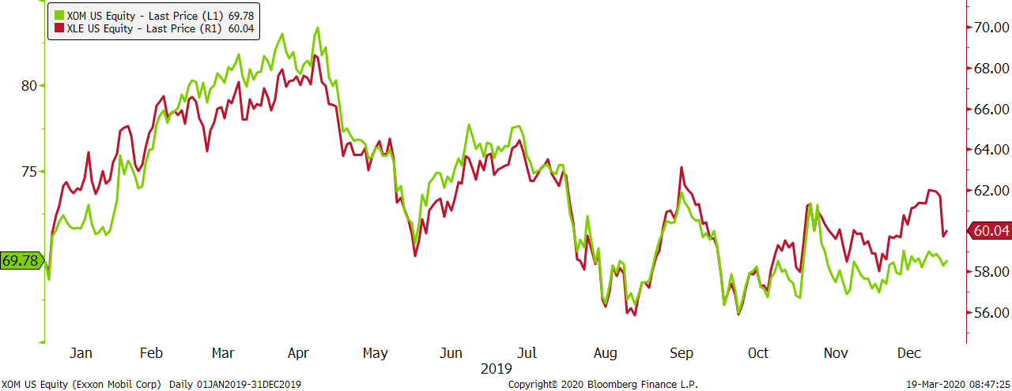

Communication Services

ALPHABET INC.
Ticker: GOOGL
Beta: 0.948

Description
Alphabet Inc. is a holding company that provides a variety of services through its subsidiaries. Alphabet was founded in 2015 by Google in order to move Google's subsidiaries to Alphabet to narrow Google’s scope. These services include web-based searches, software applications, consumer content, maps, advertisement, mobile operating systems, and hardware products. Alphabet's goal is to be the A-Z of the internet. The firm wants to provide as many services as possible to consumers. Alphabet’s subsidiaries include Nest, Calico, Google Ventures, etc. Alphabet’s revenues come from advertising services. The firm is the largest advertising platform on the internet.

Performance
Alphabet returned 24.65% in 2019 but underperformed the S&P 500 Telecommunication Sector (S5TELS) that returned 31.05%. Alphabet performed well with the index until a steady decline in price in May. The decline was due to Alphabet suspending a business deal with Huawei, a Chinese hardware firm. The suspension of the business deal was due to President Trump adding Huawei to the trade blacklist, which restricts supplying any technical support to the firm. After the drop-in price in May, the stock price steadily increased through the rest of 2019.

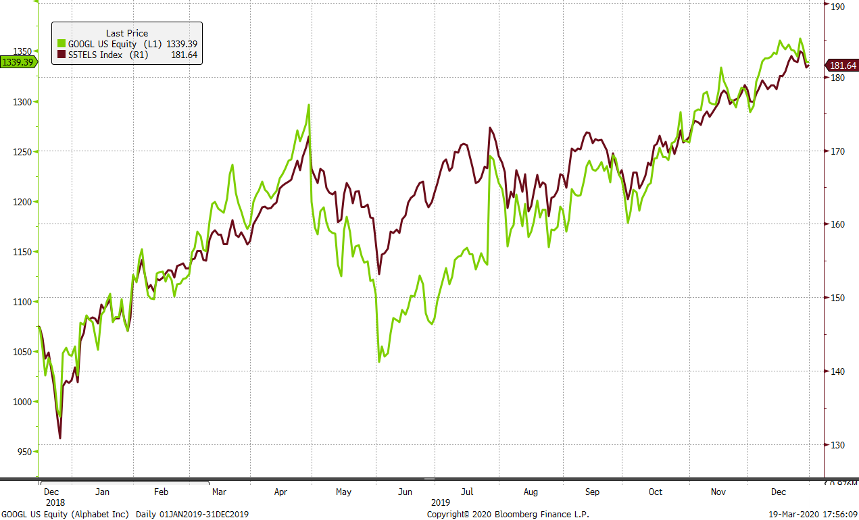

COMCAST CORP
Ticker: CMCSA
Beta: 0.918

Description
Comcast Corporation is a media and television broadcasting service. The firm offers a variety of services such as television programming, high-speed internet, and video streaming. Comcast was founded in Tupelo, Mississippi in 1963 and is headquartered in Philadelphia, Pennsylvania.

Performance
Comcast returned 25.94% in 2019 but it also underperformed the S&P 500 Telecommunications Sector that returned 31.05%. Comcast outperformed the Telecommunications Sector for most of 2019 but had a drop-in price in December due to increasing their customers streaming and service fees. After the minor drop, the stock price began to rise again toward the end of the year.

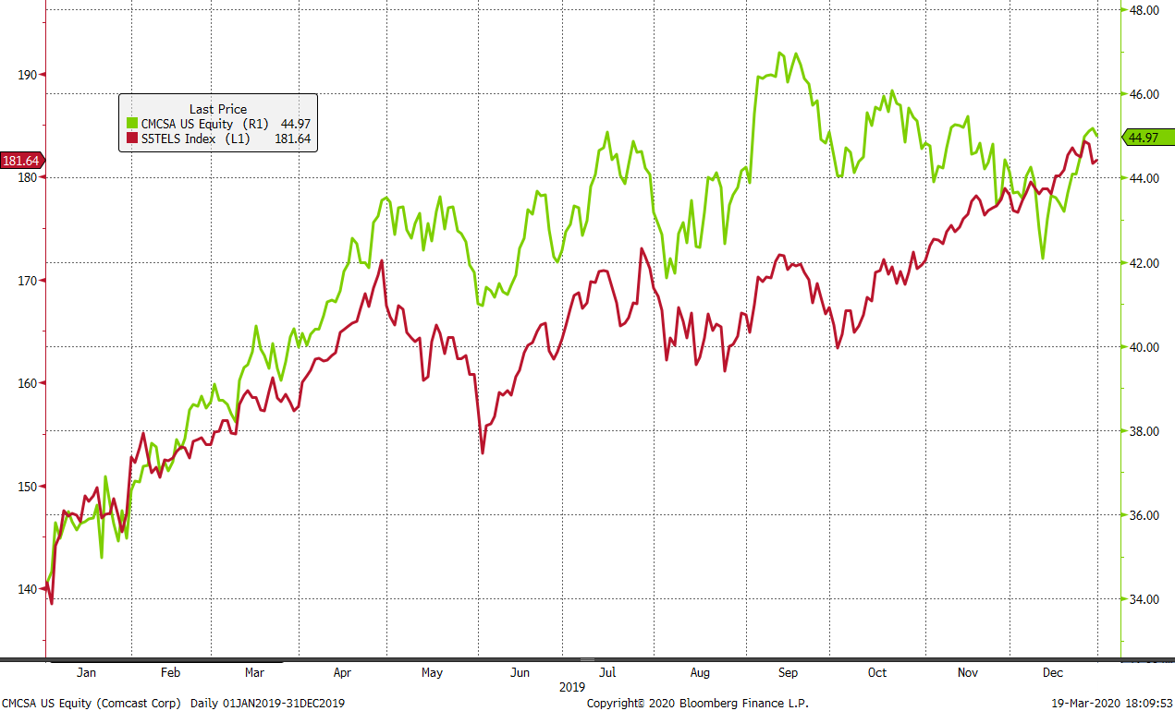

VERIZON COMMUNICATIONS
Ticker: VZ
Beta: .71

Description
Verizon was founded in 1983 and is currently headquartered in New York City, New York. Verizon Communications is a telecommunications company that provides data, wireless, wired, and internet services to their customers. Verizon is also contracted through the United States government to provide multiple different services to fit their needs. Verizon operates in two business segments, wired and wireless. As of 2019, Verizon was the number one cellular (wireless) phone service provider in the United States, this is due to their mass coverage area for 4G LTE cellular networks. Verizon has a market cap of $221.77 billion.

Performance
Verizon generated a 14.27% return for 2019, while the S&P 500 Telecommunications Sector generated a return of 31.05%, indicating that Verizon falling short by 16.78%. The weak return compared to the S&P 500 Telecommunications index can be attributed to the high cost of 5G towers that Verizon incurred in 2019. Verizon spent $17.93 billion on capital expenditures in 2019 (up from $16.65 billion in 2018), largely due to the cost of integrating 5G services into a wider area of the United States. Revenue has also been relatively flat, up .77% from 2018. Verizon is aiming to further expand its 5G services to a majority of the United States by the end of 2020, and thus generating more revenue for providing faster and more reliable service than its competitors.

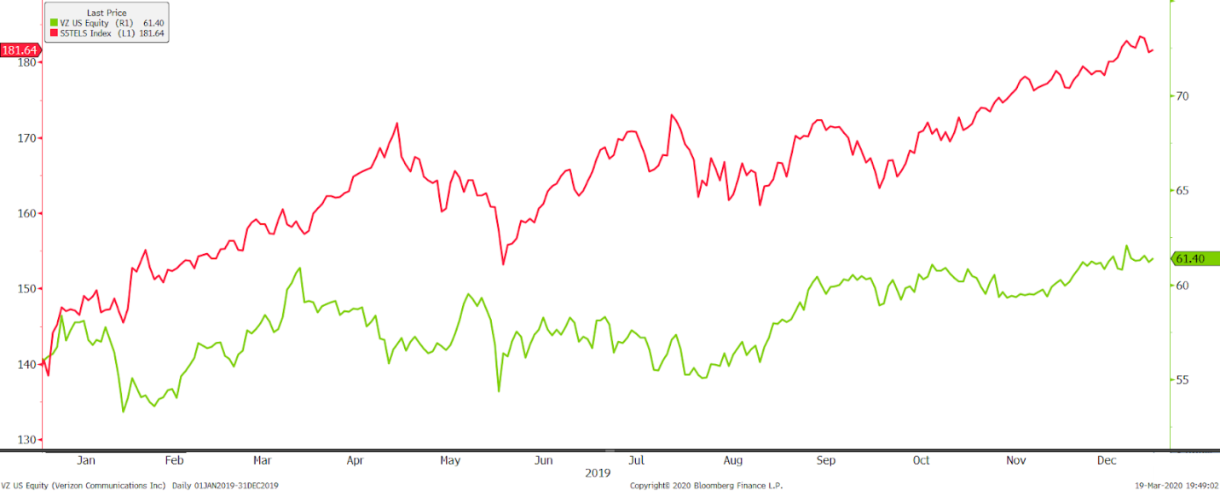

WALT DISNEY CO
Ticker: DIS
Beta: 1.00

Description
Walt Disney Company was founded in 1923 by Walt Disney and Roy Disney and is currently headquartered in Burbank, California. Walt Disney Company operates in media, consumer products, studio entertainment, and the communications segments of the market. Disney has shifted to meet consumer wants and needs over the course of their existence, making Disney less susceptible to volatility in the market. The company currently employs around 223,000 people globally and has a market capitalization of $171.39 billion.

Performance
Walt Disney Company ended 2019 with a return of 34.35%, while the S&P 500 Telecommunications Sector returned 31.05%. DIS followed the trendlines of the comparison index well until March. This was when DIS announced their new streaming service (Disney+). ln November 2019, with the launch of “Disney+”. Walt Disney Company saw quick and rapid subscribers within the first month of the service being released, helping boost revenues for the year. Walt Disney Company saw a 17.05% increase in revenue from 2018-2019, largely due to the addition of Disney+. Walt Disney Company plans to add to their Direct-to-Consumer sales with additions or upgrades to their current streaming services in 2020-2021.

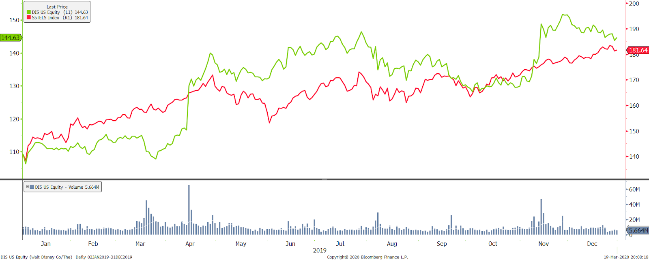

Utilities

AMERICAN ELECTRIC POWER
Ticker: AEP
Beta: 0.31

Description
American Electric Power Company, Inc. was founded in 1906, with headquarters in Columbus, Ohio. The company is a major electric utility in the U.S., serving over 5 million customers across 11 states. American Electric Power Company, Inc generates, transmits, distributes, and sells electricity to residential and commercial customers. American Electric currently operates with a market capitalization of $43.68 billion.

Performance
American Electric Power finished 2019 with returns of 30.53% and outperformed the S&P 500 Utilities index(S5inft) by 5.18%. AEP has been a consistent company over the past few years in terms of ratios and margins and looks to maintain. The company continues to show growing profits while slowly working on improvements. AEP does not appear to be making any large changes and should continue steady into the future.

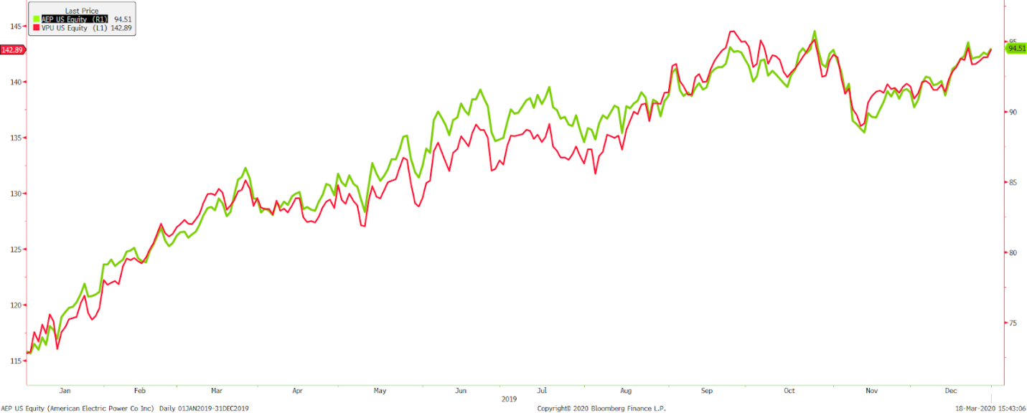

Spin Offs

ADVANSIX INC.
Ticker: ASIX
Beta: 1.95

Description
AdvanSix Inc. is a manufacturer of polymer resins. The company was founded in 2016, following a division from Honeywell. Products made consist of engineered plastics, fibers, filaments, films, electronic components, carpets, sports apparels, fishing nets, and food and industrial packaging. The company focuses on domestic sales within the United States. AdvanSix currently operates with a market capitalization of $346.1 million.

Performance
Finishing the year with a negative return of -18%, AdvanSix was 38.57% below the S&P 600 Materials sector (S6matr) return for the year. This negative return also makes AdvanSix the Bauhard Fund’s third worst performing stock in 2019. This was an unfavorable year for AdvanSix, shown through lowered sales and an unfavorable impact from market-based pricing. Though the end of 2019 was challenging for the company with a global slowdown in demand, AdvanSix believes that strategic investments in 2018 still have the company in position for long-term success.

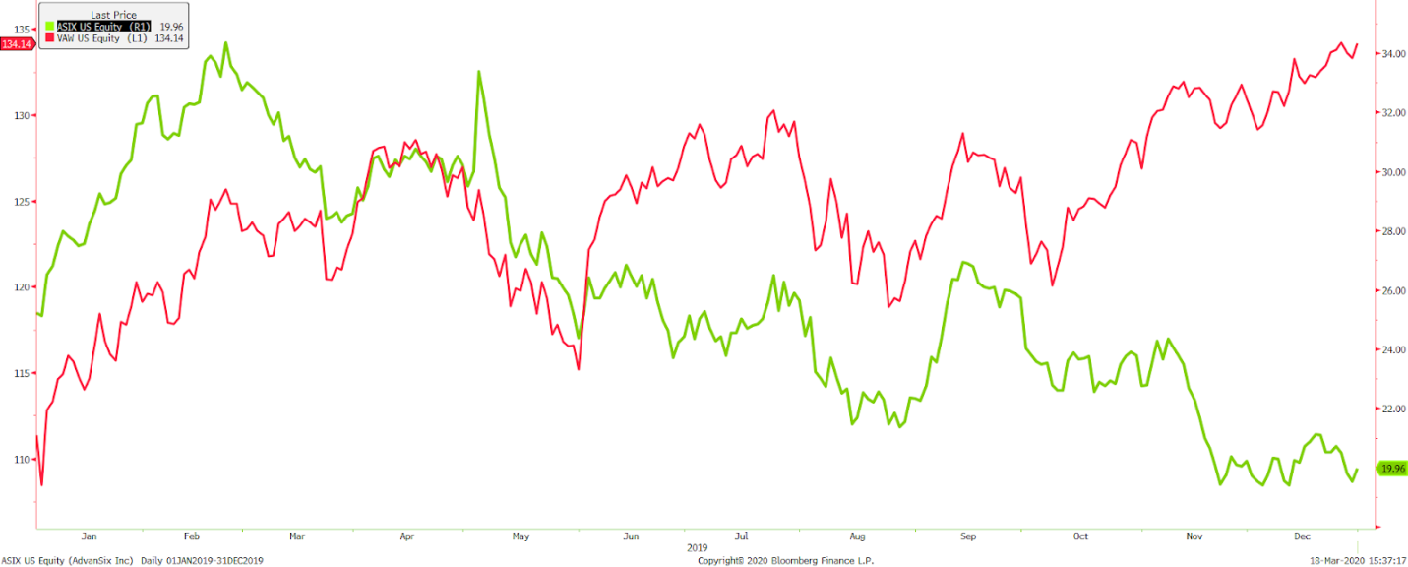

GARRETT MOTION INC.
Ticker: GTX
Beta: 1.22

Description
Garrett Motion Inc., a spin-off of Honeywell Inc in 2018, is headquartered in Rolle, Switzerland. Garrett Motion manufactures, sells and designs turbocharged and electric boosting technologies for commercial vehicles. Specifically, the firm sells to equipment manufacturers and to aftermarket entities. The turbochargers operate for gasoline, diesel, natural gas and electrified powertrains. Garrett Motion operates with a market capital of $.71 billion.

Performance
Garrett Motion Inc underperformed the consumer discretionary index by returning –19.04% in 2019. Although the firm does not have intense direct competition, it is considered highly cyclical and therefore saw a decrease in sales of its turbos for the year 2019. After the spin off with Honeywell in late 2018, Garrett Motion was overcome with a lot of debt, asbestos liabilities and significant taxes. The firm is currently suing Honeywell for the asbestos liabilities it was forced to assume. Moving forward, Garrett Motion will hope to see better sales and increasing revenue to help offset the large amount of debt coming due in the next five years.

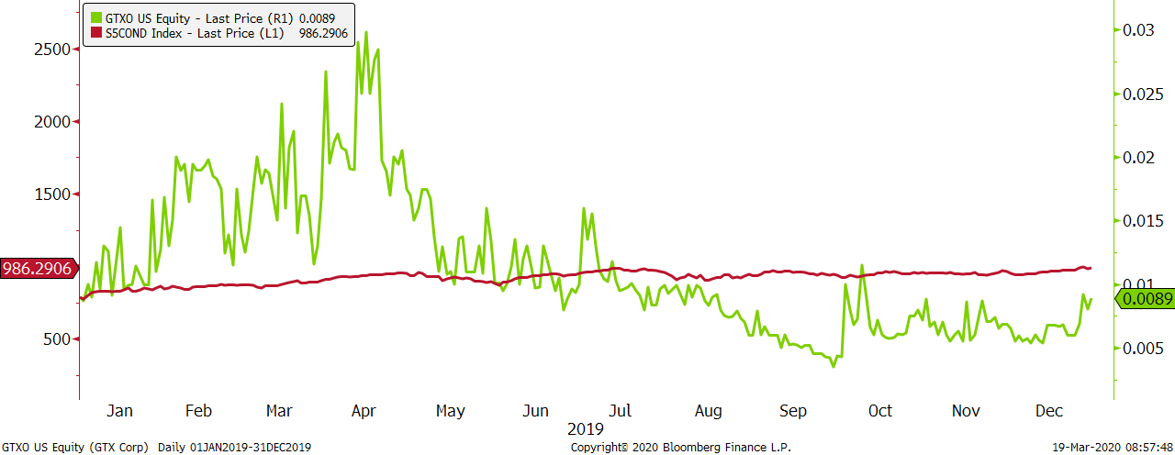

RESIDEO
Ticker: REZI
Beta: N/A

Description
Resideo Technologies was founded in 2018 from a spin-off of Honeywell International and they are currently headquartered in Austin, Texas. The company offers home technology and security systems across the globe. Products include doorbells, security cameras, and Smart Thermostats. Resdeo Technologies has a market capitalization of $585.18 million.

Performance
Resideo Technologies finished 2019 with a -41.95% return, while the comparison Vanguard ETF returned 29.54% in 2019. Resideo has seen large selloffs since the spin-off from Honeywell in 2018. Resideo missed its expected revenue by $110 million in Q3 2019, indicated by the drop in October on the graph. The Bauhard Fund owns six shares of Resideo, making up only .03% of holdings. The weak return will not have great effect on the performance of the Bauhard Fund as a whole.

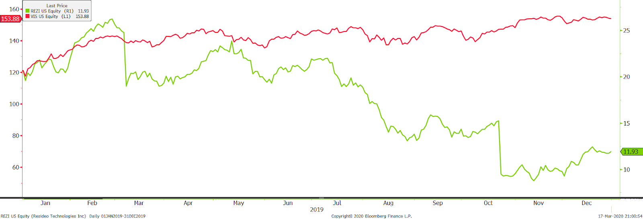

Portfolio Performance

Narrative of Performance
Throughout the year, the managers of the fund made changes to the portfolio. The Bauhard Fund returned 34.28% in 2019, increasing from a total value of $141,276.75 on January 1, 2019 to a total value of $190,097.87 on December 31, 2019.
In the Spring the management team decided to sell Starbucks. When Starbucks was sold, the stock price was down from January 1, 2019 which negatively impacted the fund’s performance for the year. The managers of the fund also sold HCP in the Spring of 2019.
The managers of the Bauhard Fund purchased several equities in 2019. In the fall semester, the fund added equity positions of 3M, Bristol-Myers Squibb, and PayPal to its holdings. The total amount of purchases amounted to $8,791.02 and total equity sales were $5,268.96. The firm also acquired Suntrust Bank through a merger with BB&T Corporation in December of 2019. Through this merger, the new equity is Truist Financial Corporation.

Fund performance vs. S&P 500

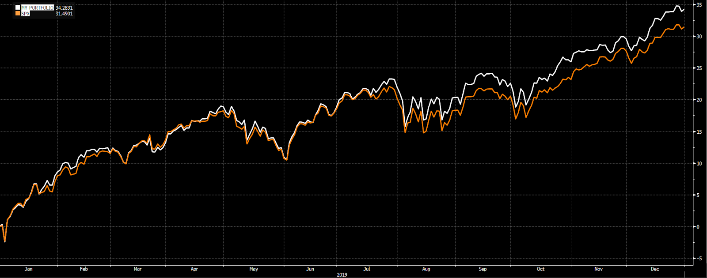

The above figure shows the performance of the Bauhard Fund compared to the S&P 500. As the chart shows, the student managed investment fund closely tracked the index and slightly outperformed the index. The Bauhard Fund graphed above includes all holdings by the Bauhard Fund, compared to the S&P 500 index fund. The actively managed portion of the Bauhard fund returned 34.28%, while the S&P 500 index returned 31.49%. The student managed portfolio outperformed the S&P 500 benchmark by 2.79%.

Performance Differences

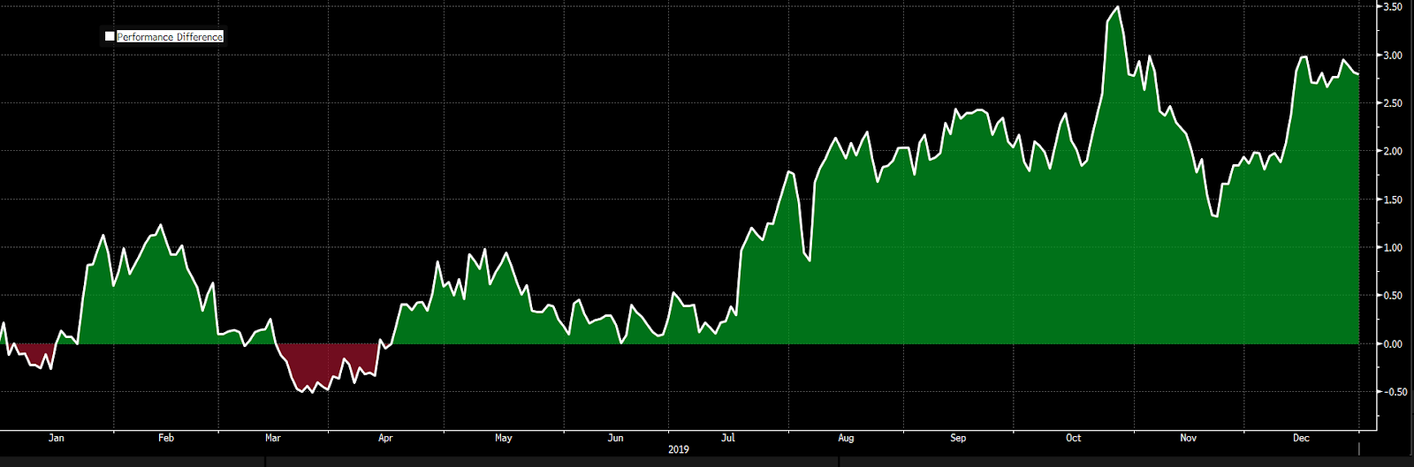

The above figure shows the performance of the Bauhard Fund for the year ending December 31, 2019. The graph shows the positive and negative performance throughout the year. The fund had positive performance in February, April, May, June, July, August, September, October, November, and December. The fund had negative performance in January and March. The second half of the year, starting after July, the fund experienced larger gains that had continued through the end of the year. The positive performance in the second half of the year can be due to the Federal Reserve lowering interest rates and also the phase one of the trade deal with China.

Volatility of Portfolio vs. S&P 500

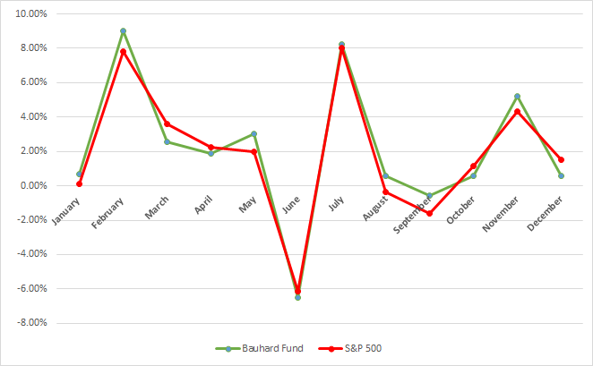

The above chart shows the month-to-month changes for the equity portion of the Bauhard Fund and the S&P 500 index. The fund closely tracked the index throughout the year. Volatility is the measure of calculating the standard deviation of the annualized returns over a given period of time. It shows the range by which the price of an equity may increase or decrease. Note that both Bauhard Fund and the S&P 500 index had a very poor month of June. The stock market had one of the worst June performances of the century in 2019. This sharp decline can be attributed to international trade tensions, fearful investors, raising interest rates, and other factors.

Performance by Sector

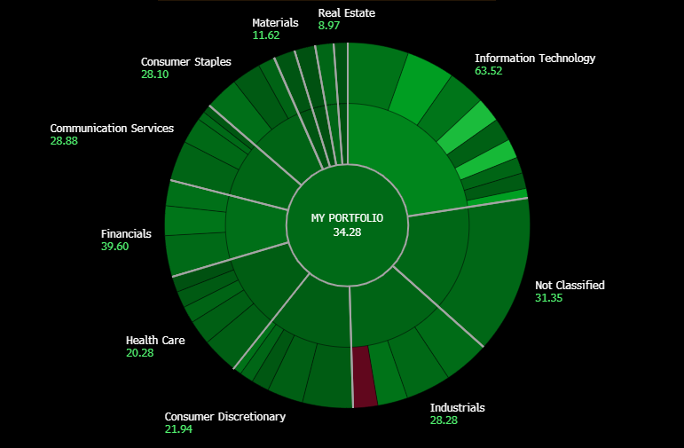
All values in terms of %.

The heat map above illustrates the total return for the Bauhard Fund and each sector by utilizing color to indicate individual sector contribution to the portfolio. Fiscal year 2019 was a bull market and that was reflected in the positive returns in each sector. Information Technology had the most return for the year at 63.52%. This sector contained 4 out of the 5 top performers in 2019 and represented 22.57% of the entire fund. Consequently, Information Technology had a major impact on the 34.28% positive return of the entire fund which is indicated by the bright green color on the heat map. Other significant gains in the portfolio include a positive return of 21.94% in consumer discretionary and 28.28% in industrials. Both of these sectors, respectively, make up 11.14% and 12.95% of the entire fund. Another significant return included the Vanguard S&P ETF, with a gain of 31.35%. The Vanguard ETF gain of 31.35% is also notable, this ETF is labeled as not classified on the heat map.

Top 5 Performers and Bottom 5 Performers

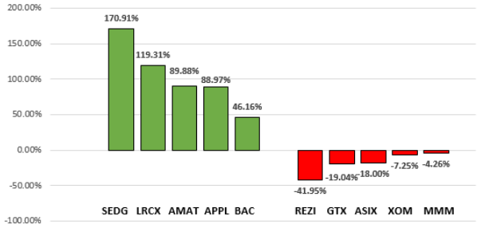

The chart above shows the top 5 and bottom 5 equity performers for 2019. In the top 5 performers, 4 of the 5 are from the information technology sector. This further illustrates the impact this sector had on the portfolio for the year. In the bottom 5, each position comes from a different sector, which shows diversification of the fund. Although these equities had negative returns in the year, managers believe that their value comes from stability. REZI, GTX, ASIX, XOM, and MMM provide the Bauhard Fund with balance in different market situations. Overall, student analysts were satisfied with positive returns in each sector and felt no reason to drop any of the bottom 5 positions listed above.

Dividend Yield Distribution

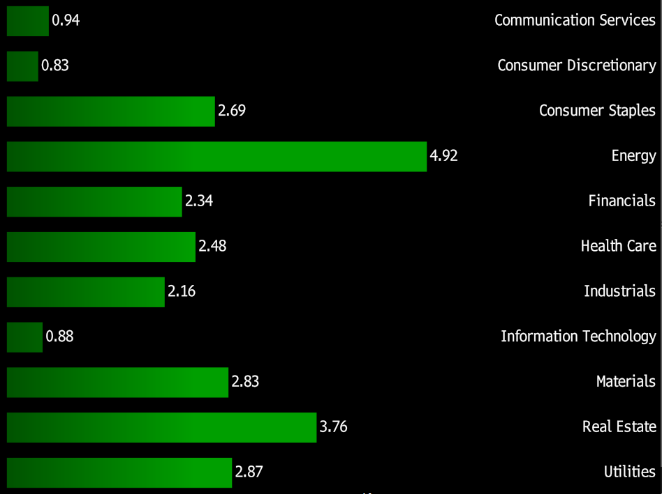

The table above shows the dividend yield of each sector in the Bauhard Fund. Cash yielded from each equity is directly reinvested into the stock it is yielded from. This technique is called “DRIP”. As the Bauhard Fund receives more dividends from the equity, the investment in the company grows. The dividend reinvestment plan allows the managers of the fund to acquire additional stock at a lower cost. DRIP is an important function of the Bauhard Fund and acts as additional cash flow for the entire fund.

Performance Measures

 | Bauhard Fund | S&P 500
Return | 34.30% | 28.88%
Required Return | 29.08% | 28.88%
Beta | 1.01 | 1
Jensen's Alpha | 5.22%
Treynor Ratio | 32.62%

The above table shows the performance of the Bauhard Fund during 2019. The Jensen’s Alpha value of 5.22% indicates a successful year for the portfolio, as the fund returned 5.22% more than it was expected to base on its benchmark fund’s return and its risk profile. This value was calculated by taking the Bauhard Fund’s 34.30% return minus its 29.08% expected return. Expected return was calculated using a risk free rate of 1.43%, based on the U.S. treasury bill, a market return of 28.88%, based on the S&P 500, and a portfolio beta of 1.01. The portfolio beta was calculated by taking a weighted average of all of the component equities’ betas. The 1.01 beta for the Bauhard Fund indicates that the portfolio almost exactly tracks the benchmark fund’s risk profile, with a very slight level of greater risk. The Treynor Ratio shows the rate of return for each additional unit of risk. It shows the rate of return for the Bauhard Fund, adjusted for the extra risk that it possessed. The 32.62% Treynor Ratio value indicates a successful year for the portfolio, as this risk adjusted rate of return is higher than the benchmark’s return of 28.88%.

Total Portfolio Value

 | 2018 | 2019
Total Equities | $113,920.88 | $163,354.73
Total Mutual Funds | $26,681.56 | $26,399.40
Total Cash | $674.31 | $343.74
Total Portfolio Value | $141,276.75 | $190,097.87

The Bauhard Fund grew $48,821.12 or 34.56% in 2019. The fund liquidated Vanguard mutual fund holdings and used cash in order to make the equity purchases during the year. The managers of the Bauhard Student Managed Investment Fund consider 2019 as a successful year for the portfolio. The fund outperformed the target index and produced a positive Jensen’s Alpha. This indicates that the decisions made by past and present student managers regarding sector allocation and individual equity selection resulted in a significantly higher return than that realized by the benchmark portfolio.

Lessons Learned

“Being a part of the Bauhard Student Managed Investment Fund has been a valuable experience in my college career. It has been a valuable experience for me professionally, educationally and also better understand markets. This was more of a real world experience than it was a class. It allowed me to gain an understanding of security selections and managing securities in the stock market. The money invested for this class is real money so that means it has actual consequences for the actions taken while managing the fund. One of the most valuable things I learned is the fundamental analysis required in selecting a security when investing. It is important that you do your research and are as knowledgeable as you can possibly be and answer the question of why you should invest your money into that stock.”
- Tyler Mestl

“Participating as one of the student managers of the Bauhard Fund for a whole year has been the most valuable learning experience that I have received in my last four years at UNK. This hands-on, active learning experience surpasses any amount of knowledge that any student could receive purely through reading a book and listening to lectures. Every decision that we make for the fund as student managers has real life consequences, and we are able to watch and learn from the successes and failures that result from our decisions. Before this learning experience, I had limited knowledge on how to effectively and accurately analyze the financial health and growth opportunities for a publicly traded company. Now, I have a deeper understanding of how investing in equities works, and I feel much more confident that I could successfully invest for myself and help others learn the basics of investing as well.”
- Brady Przymus

“Experiencing being a part of the student investment Bauhard Fund has been a crucial part to my financial learning here at UNK. Through this experience I have become Bloomberg certified, increased my vocal presentation skills, and have been able to work with a team that has one common goal. I am confident in my skills as I enter the financial workforce due to my time being a student analyst for the fund.”
- Jake Waller

“Being able to manage a portfolio has given the experience to confidently know how to make decisions for a portfolio. The Bauhard Student Managed Investment Fund has allowed me to see a stock from start to finish, including screening for the stock, doing the research, calculating the valuations, and deciding on if it would be a good addition to the portfolio. I will take this experience with me into the professional job market as I begin my career in finance.”
- Kortney Smith

“There are many take-aways from my experience being one of the managers of the Bauhard Fund. I especially enjoyed the processes of sifting through industries to find a security that might be a quality addition to our fund. Also, it was very beneficial to see how the market behaved over the course of the year and how it impacted our decision making. The lessons learned from managing the fund with my peers will be applicable to many things in my future.”
-Jared Norblade
“Being a part of the student managed Bauhard Investment Fund was valuable to me professionally and academically. The ability to apply learned knowledge to the investment fund helped me understand what clients, financial advisors and investment fund managers are constantly evaluating in order to produce the best outcome for a portfolio. Applying material from a classroom setting directly into a real world application was beneficial to me in terms of understanding key concepts to successful portfolio management. I will also be able to manage my own portfolio better after seeing what should be addressed and considered when making decisions regarding a portfolio. These experiences have best prepared me for a career moving forward in business.”
-Erin Hallman

“The Bauhard Investment Fund provided opportunities for me to work with the stock market hands on, which many students do not get to do. It gave me the opportunity to see what information is all reflective in the price of the stock, and how you can use that information to maximize your portfolio value.”
- Codey Krell

“Participating as an active student manager for the Bauhard Fund has been the most challenging and insightful experience I have had at UNK. As a manager you are responsible for asset allocation, securities research and selection, balancing the portfolio, and analyzing the portfolios risk. The hands on learning experienced provided by actively managing a real portfolio is certainly irreplaceable.”
- Harrison Webb

“Managing the Bauhard Fund helped give me experience and a better understanding of the stock market. Learning how to analyze a company and calculate valuations was very beneficial, especially with the bonus of using Bloomberg. Working with actual money increased how seriously investments were taken, having real consequences if the fund was poorly managed. This was an opportunity the majority of people do not receive.”
- Bryce Kelley

“This past year managing the Bauhard Fund has been such an extraordinary experience. Applying skills and tactics learned in class to a real world, hands-on learning experience is something most students don’t get the opportunity to do. Managing this fund has taught me so much about portfolio management and using a real-world example is an excellent way to help prepare myself for the professional world after college.
I can’t wait to take everything I’ve learned in this class and apply it to the real world, as I begin my finance career.”
- Alex Harbols

“By managing the Bauhard Fund, I learned the financial investment theory to guide the initial stock investment practice, and make up for the lack of theoretical knowledge in practice. At the same time, the feasibility of the textbook theory I studied was verified. In step-by-step learning, I learned how to choose stocks. I believe that managing the Bauhard Fund will not only help us find a good job, but also benefit us for life.”
- Xueyuan Fan

Analysts

